1. You are developing an ASP.NET MVC web application in Visual Studio 2012. The application requires several thousand content files. All content is hosted on the same IIS instance as the application. You detect performance issues when the application starts. You need to resolve the performance issues. What should you do?
2. Implement HTTP caching in the ASP.NET MVC controllers.
3. **Combine the content files by using ASP.NET MVC bundling.**
4. Install a second IIS instance.
5. Move the content to a Windows Azure CDN.
6. You are developing an ASP.NET MVC application that uses forms authentication. The user database contains a user named LibraryAdmin.

You have the following requirements:

You must allow all users to access the GetBook method.

You must restrict access to the EditBook method to the user named LibraryAdmin.

You need to implement the controller to meet the requirements. Which code segment should you use? (Each correct answer presents a complete solution. Chooseall that apply.)

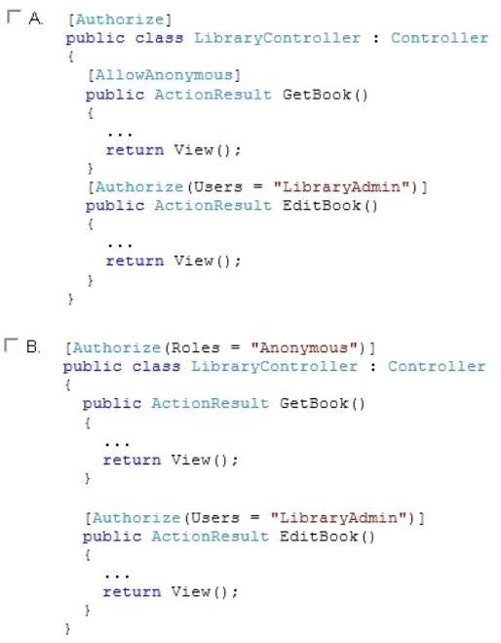

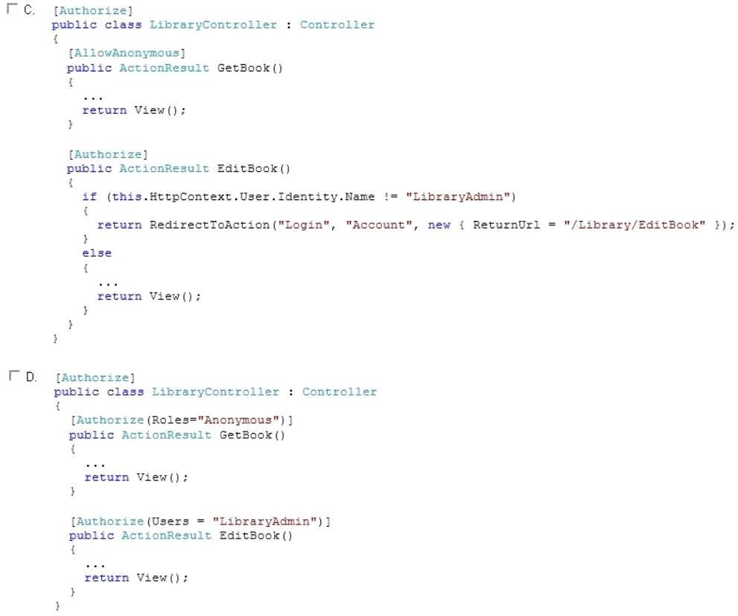

1. **Option A**
2. Option B
3. **Option C**
4. Option D
5. DRAG DROP

You are developing an ASP.NET MVC application that takes customer orders. Orders are restricted to customers with IP addresses based in the United States. You need to implement a custom route handler. How should you implement the route handler? (To answer, drag the appropriate line of code to the correct location or locations. Each line of code may be used once, more than once, or not at all. You may need to drag the split bar between panes or scroll to view content.)

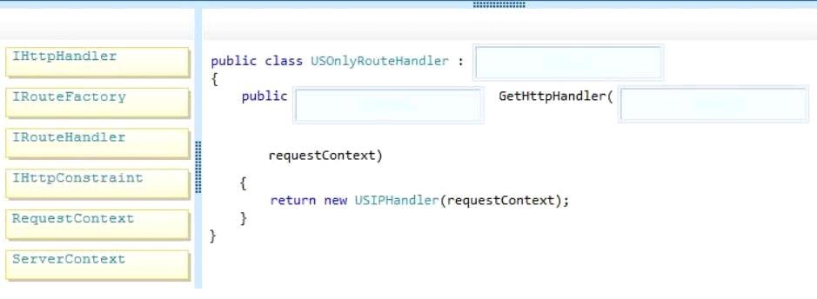

1. **IRouteHandler,IHttpHandler,RequestContext**
2. RequestContext,IHttpHandler,IRouteHandler
3. ServerContext,RequestContext,IRouteHandler
4. IRouteHandler,RequestContext,ServerContext
5. You are designing an HTML5 website. You need to design the interface to make the content of the web page viewable in all types of browsers, including voice recognition software, screen readers, and reading pens. What should you do? (Each correct answer presents a complete solution. Choose all that apply.)
6. **Annotate HTML5 content elements with Accessible Rich Internet Application (ARIA) attributes.**
7. Convert HTML5 forms to XForms.
8. Ensure that HTML5 content elements have valid and descriptive names.
9. **Use HTML5 semantic mark-up elements to enhance the pages.**
10. Use Resource Description Framework (RDF) to describe content elements throughout the entire page.
11. DRAG DROP

You are developing an ASP.NET MVC web application in Visual Studio 2012. The application has a model named ReservationLocation that contains properties named City and State. The view that displays reservations has a single text box named loc for entering the location information. The location is entered as city, state. There are action methods that have ReservationLocation as a parameter type. You need to ensure that the City and State properties are correctly populated. How should you implement model binding for the ReservationLocation type? (To answer, drag the appropriate code segment to the correct location or locations. Each code segment may be used once, more than once,or not at all. You may need to drag the split bar between panes or scroll to view content.)

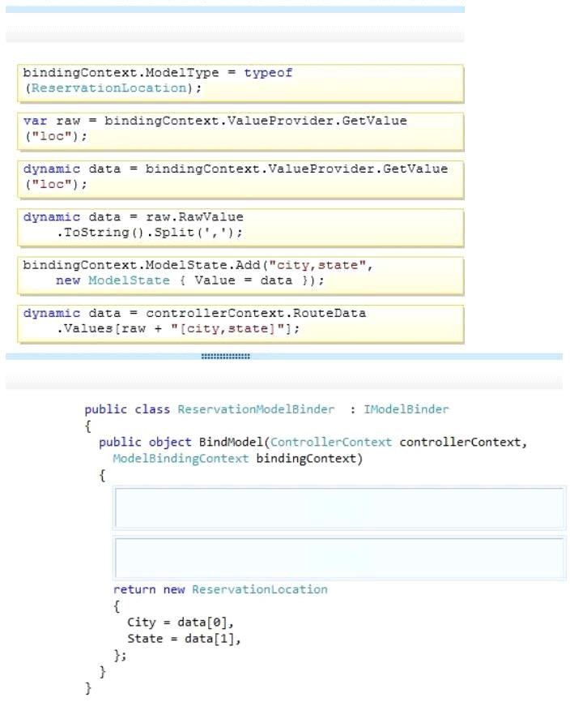

1. **var raw=binding.Context.ValueProvider.GetValue(“loc”);**
2. **dynamic data=raw.RawValue.ToString().Slit(‘,’):**
3. dynamic data= binding.Context.ValueProvider.GetValue(“loc”);
4. You are developing an ASP.NET MVC web application in Visual Studio 2012. The application requires several thousand content files. All content is hosted on the same IIS instance as the application. You detect performance issues when the application starts. Youneed to resolve the performance issues. What should you do?
5. Implement HTTP caching in the ASP.NET MVC controllers.
6. **Combine the content files by using ASP.NET MVC bundling.**
7. Install a second IIS instance.
8. Move the content to a Windows Azure CDN.
9. You are developing an ASP.NET MVC application in Visual Studio 2012. The application supports multiple cultures. The application contains three resource files in the Resources directory:

My Dictionary.resx

MyDictionary.es.resx

MyDictionary.fr.resx

Each file contains a public resource named Title with localized translation. The application is configured to set the culture based on the client browser settings. The application contains a controller with the action defined in the following code segment. (Line numbers are included for reference only.) You need to set ViewBag.Title to the localized title contained in the resource files. Which code segment should you add to the action at line 03?

1. ViewBag.Title = HttpContext.GetGlobalResourceObuect(“MyDictionary”, “Title”);
2. ViewBag.Title = HttpContext.GetGlobalResourceObject(“MyDictionary”, “Title”, new System.Globalization. CultureInfo(“en”));
3. **ViewBag.Title = Resources.MyDictionary.Title;**
4. ViewBag.Title = HttpContext.GetLocalResourceObject(“MyDictionary”, “Title”);
5. You are testing an ASP.NET application. The test plan requires that tests run against the application’s business layer. You need to use the test project template that meets this requirement. Which template should you use?
6. Web Test Project
7. Load Test Project
8. **Unit Test Project**
9. Coded Test Project
10. You are authoring unit tests. The unit tests must test code that consumes sealed classes. You need to create, maintain, and inject dependencies in the unit tests. Which isolation method should you use?
11. T4 text templates and code generation
12. Stub types
13. **Shim types**
14. Hard-coded implementation
15. You are developing an ASP.NET MVC web application that includes the following method.

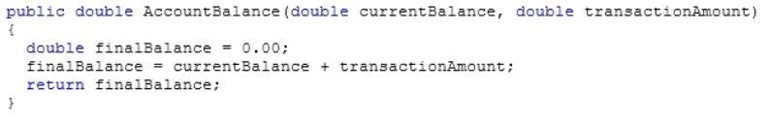

You need to test the AccountBalance method. Which unit test should you use?

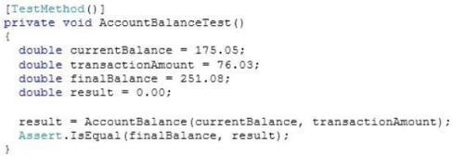

B.



**C.**



D.



1. You are developing an ASP.NET MVC application by using Visual Studio 2012. The application throws and
2. handles exceptions when it runs. You need to examine the state of the application when exceptions are thrown. What should you do?
3. **From the DEBUG menu in Visual Studio 2012, selectExceptions. Enable the Thrown check box for Common Language Runtime Exceptions.**
4. From the DEBUG menu in Visual Studio 2012, selectExceptions. Disable the User-unhandled check box for Common Language Runtime Exceptions.
5. Add the following code to the Web.config file of the application.

<customErrors mode=”On”>

<error statusCode=”500″ redirect=”CustomErrors.html” /> </customErrors>

1. Add the following code to the Web.config file of the application.

<customErrors mode=”On” >

<error statusCode=”404″ redirect=” CustomErrors.html”/> </customErrors>

1. You are developing an ASP.NET MVC news aggregation application that will be deployed to servers on multiple networks. The application must be compatible with multiple browsers. A user can search the website for news articles. You must track the page number that the user is viewing in search results. You need to program the location for storing state information about the user’s search. What should you do?
2. Store search results and page index in Session.

B. Use Application state to store search terms and page index.

C. **Use QueryString to store search terms and page index.**

1. Store search results and page index in TempData
2. You are developing an ASP.NET MVC application. The application is deployed in a web farm and is accessed by many users. The application must handle web server failures gracefully. The servers in the farm must share the state information. You need to persist the application state during the session. What should you implement?

A**. A state server**

B. Cookieless sessions

C. A web garden on the web servers

D. An InProc session

1. You are developing an ASP.NET MVC application that displays stock market information. The stock market information updates frequently and must be displayed in real-time. You need to eliminate unnecessary header data, minimize latency, and transmit data over a full-duplex connection. What should you do?
2. Implement long-running HTTP requests.
3. Instantiate a MessageChannel object on the client.
4. Implement WebSockets protocol on the client and the server.
5. Configure polling from the browser.
6. You are building an ASP.NET web application. You must test the web application in multiple browsers at the same time. You need to ensure that the application can use the Browser Link feature. Which two actions should you perform? Each correct answer presents part of the solution.
7. In the web.config file, set the value of the debug attribute to False.
8. **In the web.config file, set the value of the debug attribute to True.**
9. **Enable Browser link.**
10. Use an external editor for webpages.
11. Enable source control server support.
12. You are developing an ASP.NET MVC application that will run in a shared environment. The application requests the user’s password, and then uses the password to sign data. You need to minimize the potential for the password to be discovered by other processes that run in the shared environment. What should you do?
13. Add the SecuritySafeCriticalAttribute attribute to the methods which process the password.
14. Store the password in a SecureString instance.
15. Encrypt the password on the web page, and decrypt the password in the MVC application.
16. **Run the code that processes the password in its own AppDomain.**
17. You develop an ASP.NET MVC application. The application is configured for claims-based authentication by using Windows Identity Foundation (WIF). You need to access the claims in the WIF token. Which code segment should you use?
18. Thread.CurrentPrincipal.Identity;
19. **((IClaimsPrincipal)Thread.CurrentPrincipal).Identities[0].Claims;**
20. Thread.CurrentPrincipal;
21. ((IClaimsPrincipal)Thread.CurrentPrincipal).Identities[0].IsAuthenticated;
22. You are developing an ASP.NET MVC application. The application has a contact view includes a form for editing the displayed contact. You need to save the Contact object model when the form is posted back to the EditContact method using a POST method request. Which code segment should you use? (Each correct answer presents a complete solution. Choose all that apply.)
23. **public ActionResult EditContact()**

**{**

**var c = newContact()**

**{**

**FirstName = Request.QueryString [‘”FirstName”‘],**

**LastName = Request.QueryString[“LastName”]**

**};**

**SaveContact(c);**

**return View(c);**

**}**

1. **public ActionResult EditContact(Contact c)**

**{**

**SaveContact(c);**

**return View(c);**

**}**

1. public ActionResult EditContact(FormCollection values)

{

var c = newContact()

{

FirstName = values [”FirstName”],

LastName = values[“LastName”]

};

SaveContact(c);

return View(c);

}

1. public ActionResult EditContact(QueryStringProvider values)

{

var c = newContact()

{

FirstName = values.GetValue[‘”FirstName”‘],

LastName = values.GetValue [“LastName”]

};

SaveContact(c);

return View (c);

}

1. You are developing an ASP.NET MVC application. The application uses a set of custom exceptions to log errors that occur during the execution of an action. You need to develop a class that implements logging. Which interface should you implement?
2. **IExceptionFilter**
3. IActionFilter
4. IClientValidatable
5. IResultFilter
6. You create an ASP.NET MVC application. You host the application by using the Open Web Interface for .NET (OWIN). You run the following command by using the NuGet Package Manager console:

install-package Microsoft.AspNet.SignalR

You plan to implement real-time push notifications from the server using ASP.NET SignalR. You need to complete the ASP.NET SignalR implementation. Which three steps should you perform? Each correct answer presents part of the solution.

A**. Create a hub class to push content to clients.**

B. Create a class that derives from the PersistentConnection class. Use the derived class to push content to clients.

**C. Use the SignalR jQuery library in a web page to send messages to the hub and display updates from the hub.**

**D. Map a SignalR hub to the app builder pipeline by using an OWIN startup class.**

E. Start the SignalR hub asynchronously and respond to the appropriate callback methods.

1. You are developing an ASP.NET MVC application. Devices that use many different browsers will use the application. You have the following requirements:

– Content must display correctly when a device is in landscape or portrait orientation.

– Content must not scale when the device orientation changes.

– Content must be displayed by using the maximum available screen space.

– The application must render properly in Internet Explorer 8 or later versions.

You need to configure the application. Which two actions should you perform? Each correct answer presents part of the solution.

A. Use JavaScript to evaluate the window.innerWidth and window.innerHeigh properties.

**B. Set the value of the width property for the viewport meta tag to device-width.**

C. Use CSS to target the HTML element on each page. Set the values of the width and height properties to 100%.

**D. Use CSS media queries to target screen size, device orientation, and other browser capabilities.**

1. DRAG DROP

You are developing an ASP.NET MVC application. You plan to use OAuth to authenticate users to the application. You need to use the correct authentication data in the application.

What should you do? To answer, drag the appropriate data element to the correct location or locations. Each data element may be used once, more than once, or not at all. You may need to drag the split bar between panes or scroll to view content.

Select and Place:

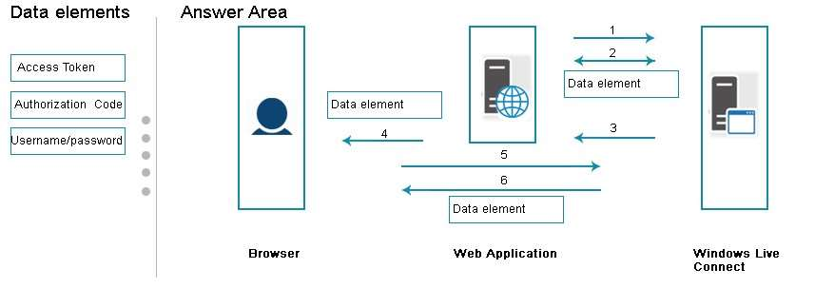

Answer:

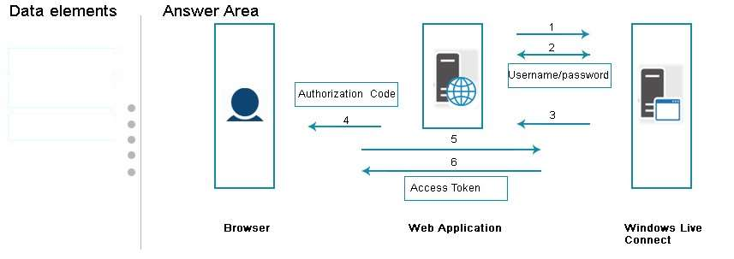

1. The application includes the following method. (Line numbers are included for reference only.)

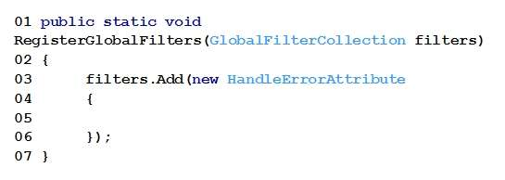

When users attempt to retrieve a product from the product page, a run-time exception occurs if the product does not exist. You need to route the exception to the CustomException.aspx page.

Which line of code should you insert at line 05?

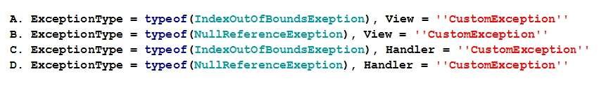

Answer: B

1. You are developing an ASP.NET MVC application to display product information. The application has two views. The first view displays a list of product names. When you select a product name, the second view shows detailed information for the product that is selected. The product detail view receives a query string value that contains as identifier for the product that is selected. The product controller for the application has the following requirements:

* The product list and product details must use output caching.
* The list of products must be cached daily.
* The product details view must cache data for one hour, based on the product that is selected.

You need to implement the product controller. How should you complete the relevant code? To answer, select the appropriate code from each list in the answer area.

Hot Area:

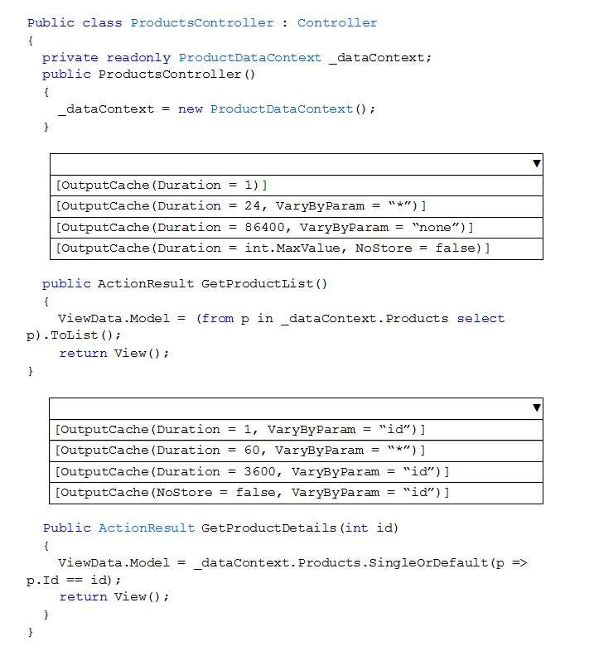

Answer:

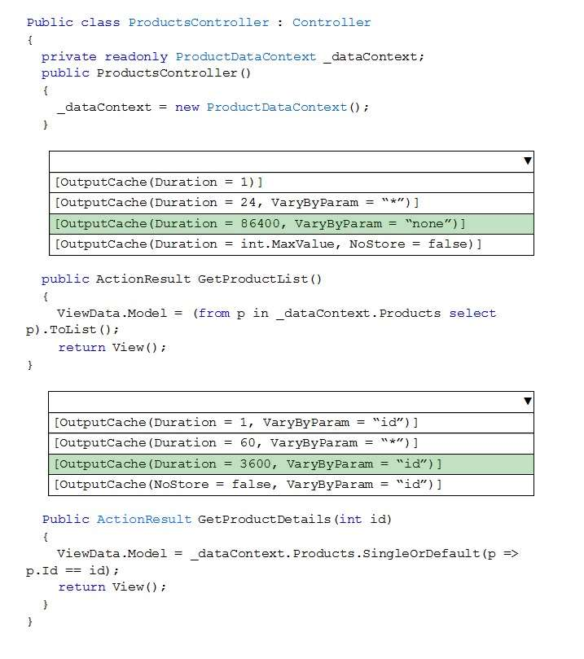

1. DRAG DROP

You are developing an ASP.NET MVC application. You need to choose the appropriate Visual Studio templates to use for each test goal. Which Visual Studio Unit Test project templates should you use? To answer, drag the appropriate Unit Test project template to the correct test goal or test goals. Each project template may be used once, more than once, or not at all. You may need to drag the split bar between panes or scroll to view content.

Select and Place:

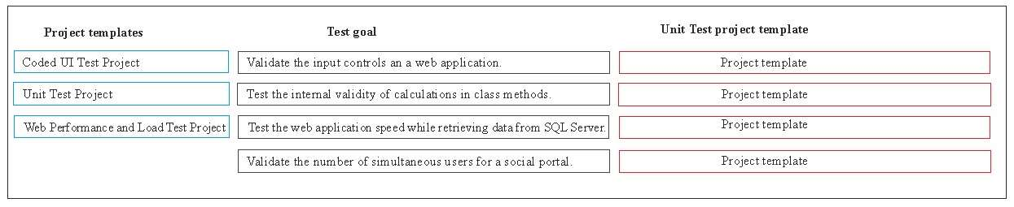

Answer:

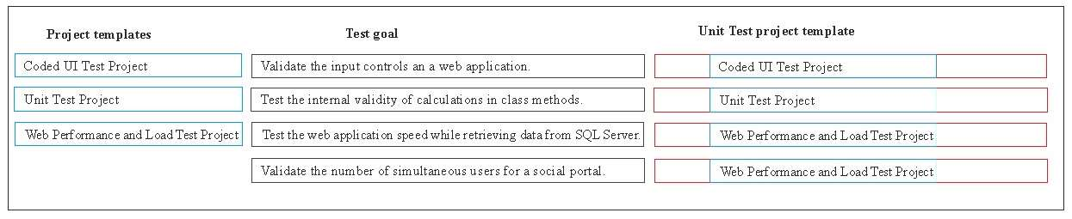

1. HOTSPOT  
   You are building an ASP.NET application. You develop the following unit test code. Line numbers are included  
   for reference only.  
   01 [TestClass]  
   02 public class UnitTest1  
   03 {  
   04 protected string _name;  
   05 protected float _expenses;  
   06 protected float _income;  
   07 protected float _payment;  
   08 protected float _balance;  
   09 public void AddCustomer(string name, float income, float payment, float balance)  
   10 {  
   11 _name = name;  
   12 _expenses = expenses;  
   13 _income = income;  
   14 _payment = payment;  
   15 _balance = balance;  
   16 CheckName();  
   17 DebRatio();  
   18 CheckBalance();  
   19 }  
   20 [TestMethod]  
   21 public void CheckName()  
   22 {  
   23 Assert.IsNotNull(_name, “CheckName failed unit test”);  
   24 }  
   25 [TestMethod]  
   26 public void DebRatio()  
   27 {  
   28 Assert.AreSame(_income, _payment, “DebRatio failed unit test”);  
   29 }  
   30 [TestMethod]  
   31 public void CheckBalance()  
   32 {  
   33 Assert.IsTrue(_balance >= 0.0f, Check balance failed unit test.”);  
   34 }  
   35}  
   You run the following line of code:  
   AddCustomer(“Contoso”, 0, 100, -1);  
   You need to evaluate the unit test results. For each of the following statements, select Yes if the statement is  
   true. Otherwise, select No.  
   Hot Area:

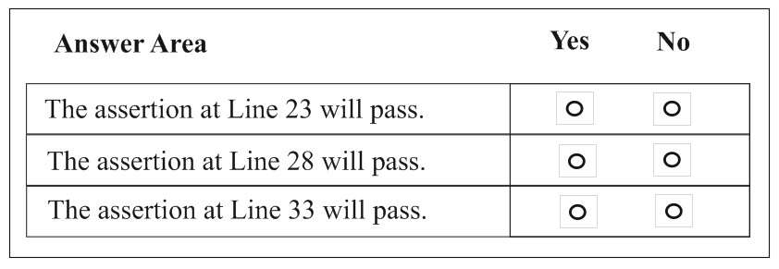

Answer:

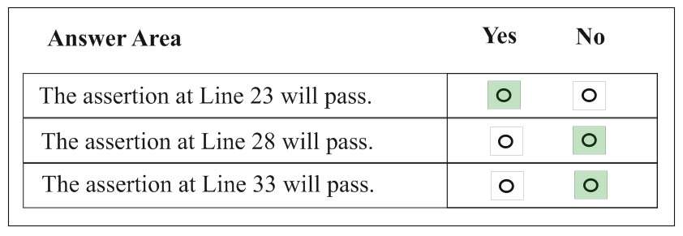

1. DRAG DROP

You are building an ASP.NET application for a purchasing system. The application has a method named CalculateBalance in the Purchasing class. You need to create a unit test for the CalculateBalance method. Which five actions should you perform in sequence? To answer, move the appropriate actions from the list of actions to the answer area and arrange them in the correct order.

Select and Place:

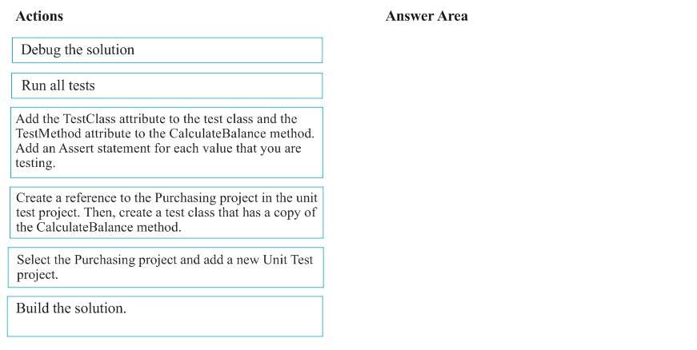

Answer:

* 1. Select the Purchasing project and add a new Unit test project
  2. Create a reference to the Purchasing project in the unit test project. Then create a test class that has a copy of the CalculateBalance method
  3. Add the TestClass attribute to the test class and the TestMethod Attribute to the CalculateBalance method. Add an Assert statement for each value that you are testing.
  4. Build the solution
  5. Run all tests

1. HOTSPOT

You develop an ASP.NET MVC application that includes the following class. Line numbers are included for reference only.

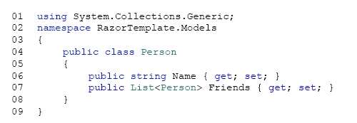

You must use the Razor view engine to display all property values for the class.

You need to implement the view. How should you complete the relevant code? To answer, select the appropriate code segment from each list in the answer area.

Hot Area:

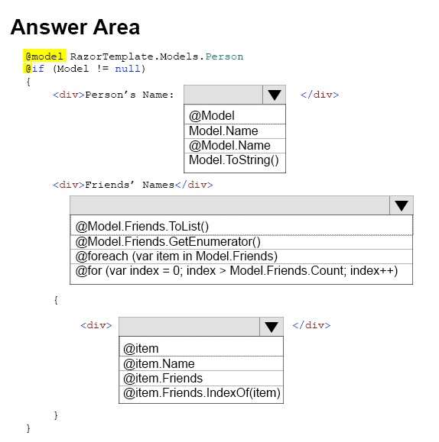

**Answer:**

* 1. **@Model.Name**
  2. **@foreach(var item in Model.Friends)**
  3. **@item.Name**

1. You are developing an ASP.NET MVC application that will be deployed on local Internet Information Services (IIS) servers and on an Azure Web Role. You must log events for the application when it is deployed locally and on Azure. You must not deploy additional services. You need to implement a logging solution. Which two technologies can you use? Each correct answer presents a complete solution.
2. **event log**
3. **trace**
4. console
5. named pipe
6. You are developing an ASP.NET MVC application. The application includes the following HomeController class. Line numbers are included for reference only.

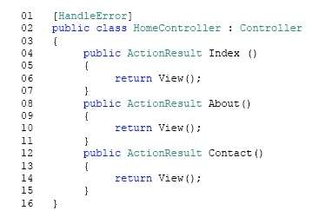

During testing, all errors display an ASP.NET error page instead of the expected error view.

You need to ensure that the error view displays when errors occur.

What should you do?

1. Replace line 01 with the following code segment: [HandleError(View=”Error”)]
2. **In the web.config file, set the value of the customErrors property to On.**
3. Replace line 01 with the following code segment: [HandleError(ExceptionType=typeof(SystemException))]
4. Create a custom error page namedError.aspx. Save the file in the Views\\Shared folder for the project.
5. DRAG DROP

You need to ensure that URLs for log manipulation are mapped to the controller.

You have the following code:

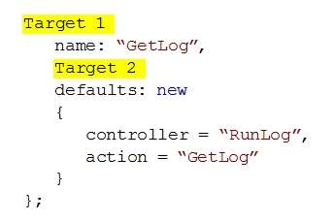

Which code segments should you include in Target 1 and Target 2 to map the URLs? To answer, drag the appropriate code segments to the correct targets. Each code segment may be used once, more than once, or not at all. You need to drag the split bar between panes or scroll to view content.

Select and Place:

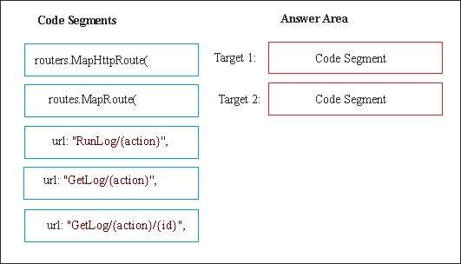

Answer:

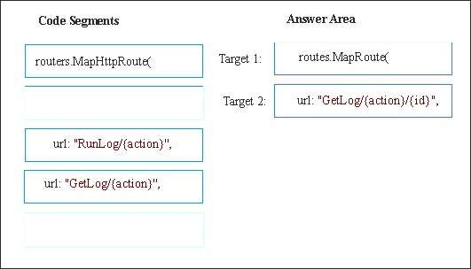

1. DRAG DROP

You are developing an ASP.NET MVC application. You must handle any first chance exceptions that the application throws. The exception handler has the following requirements:

Catch any first chance exceptions thrown by the default app domain.

Display the name of the app domain that caused the exception.

Display the message for the exception.

You need to implement the exception handler.

How should you complete the relevant code? To answer, drag the appropriate code segment to the correct location or locations. Each code segments may be used once, more than once, or not at all. You may need to drag the split bar between panes or scroll to view content.

Select and Place:

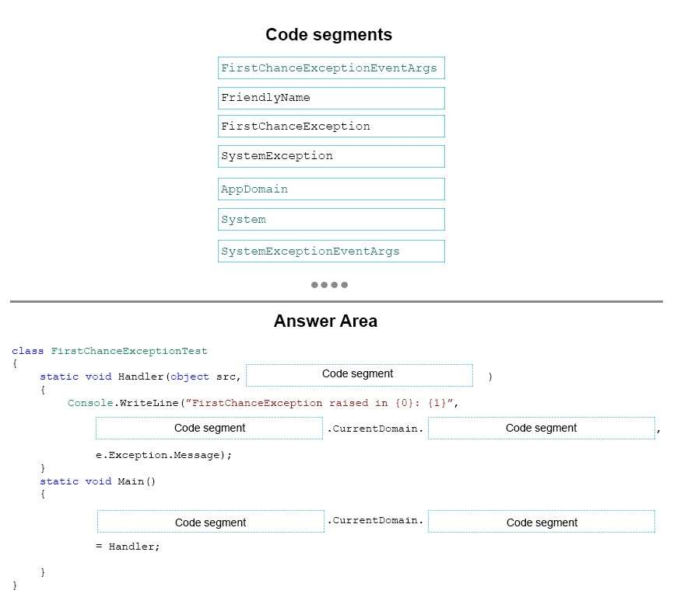

Answer:

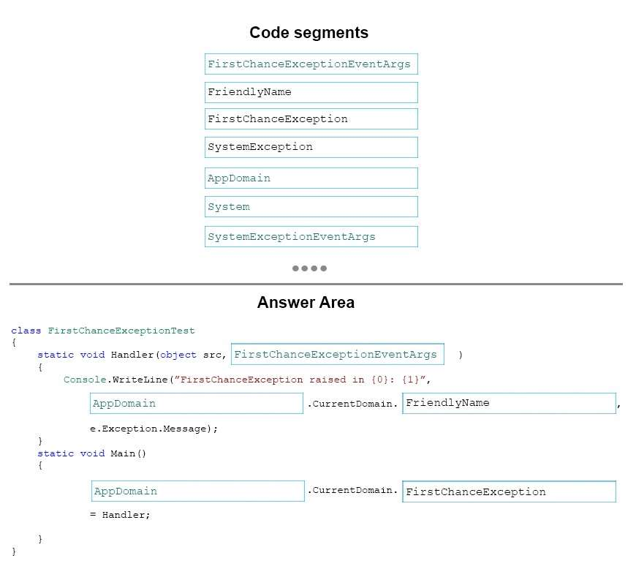

1. You are developing an ASP.NET MVC application. The application includes the following method. Line numbers are included for reference only.

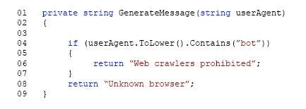

The application calls the GenerateMessage method before displaying each page. The GenerateMessage method throws NullReferenceException exceptions. You need to use Code Contracts to prevent the exceptions. Which code segment should you insert at line 03?

1. Contract.Assume(userAgent !=null);
2. **Contract.Requires(userAgent !=null);**
3. Contract.Ensures(userAgent !=null);
4. Contract.Invariant(userAgent !=null);
5. HOTSPOT
6. You develop an ASP.NET MVC application. You are creating a new layout page by using the Razor view engine. The layout page has the following requirements:

Render the content of a section named scripts at the bottom of the layout page.

Render the content of a section named featured just above the body of the page.

Render a StyleBundle named ~/Content/css.

You need to implement the layout page. How should you complete the relevant Razor markup? To answer, select the appropriate Razor markup from each list in the answer area.

Hot Area:

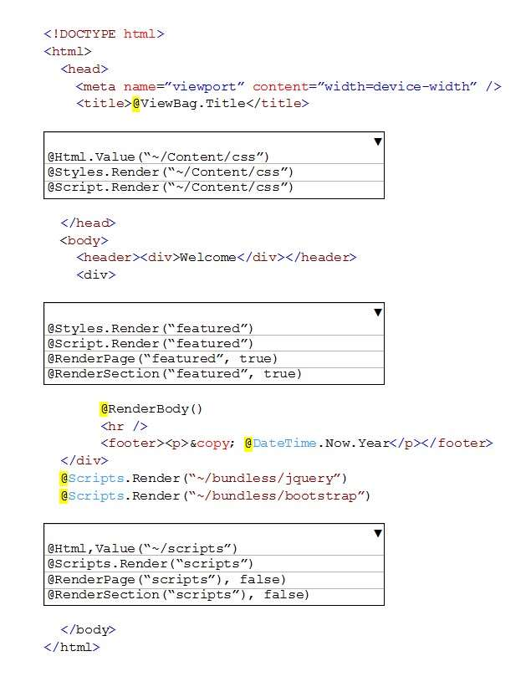

Answer:

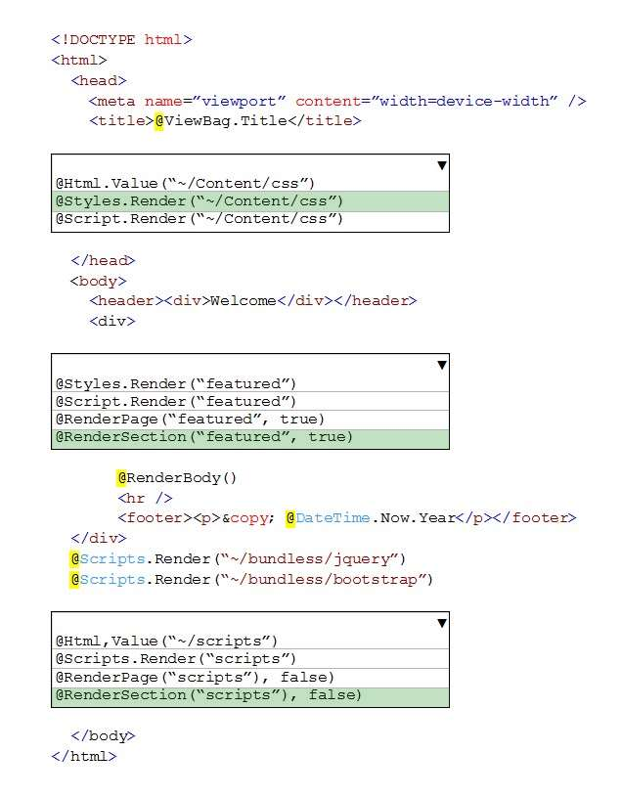

1. DRAG DROP

You develop an ASP.NET MVC application. You plan to implement ASP.NET SignalR for real-time push notifications. The application includes the following class:

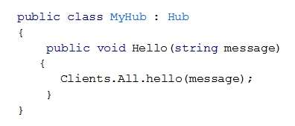

You need to display the message. How should you complete the relevant code segment? To answer, drag the appropriate code segment to the correct location or locations. Each code segment may be used once, more than once, or not at all. You may need to drag the split bar between panes or scroll to view content.

Select and Place:

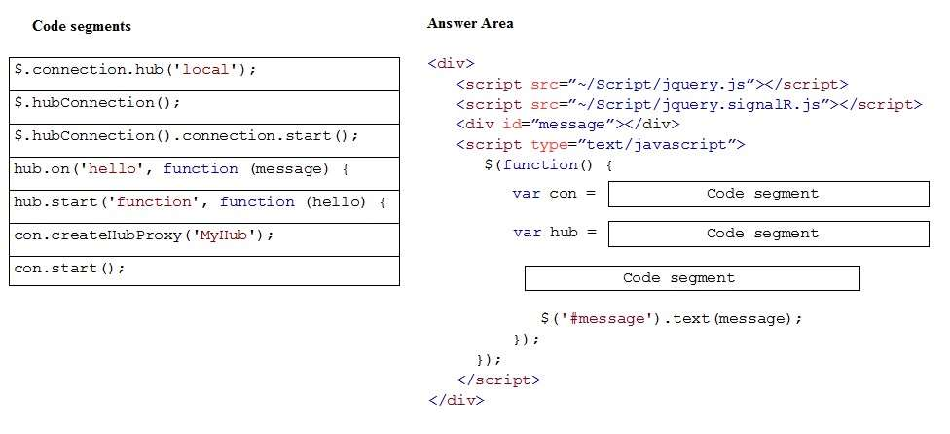

Answer:

* + 1. $.hubCconnection();
    2. con.createHubProxy(“MyHub”)
    3. hub.on(“hello”, function(message){

1. DRAG DROP

You are designed a hybrid application that runs across a Microsoft Azure data center and your company’s onpremise enterprise environment. You have the following requirements:

* Windows Communication Foundation (WCF) services that reside within the corporate enterprise network must be securely exposed to the public cloud.
* A firewall connection and intrusive changes to the corporate network infrastructure are not allowed.

You need to design the application to meet the requirements. How should you design the application? To answer, drag the appropriate item to the correct location or locations. Each item may be used once, more than once, or not at all. You may need to drag the split bar between panes or scroll to view content.

Select and Place:

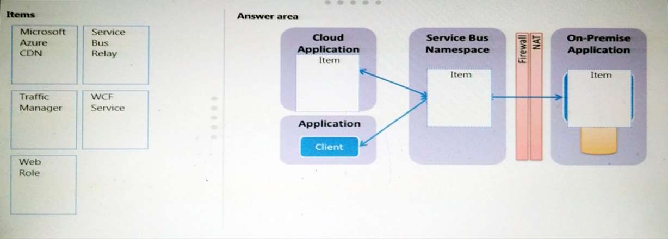

Answer:

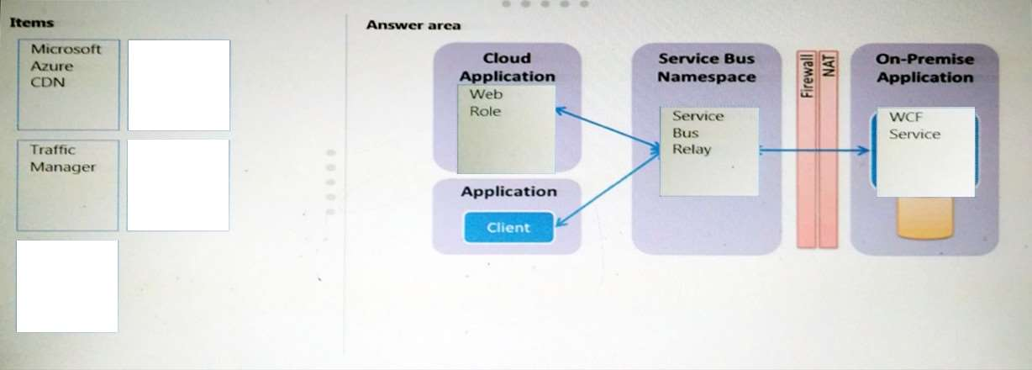

1. You are developing an ASP.NET MVC application to be used on the Internet. The environment does not use Active Directory. Users must be able to log on to the application to maintain their personal preferences. You need to use the least amount of development effort to enable users to log on. What should you do?
2. Enable Digest authentication.
3. Enable Windows authentication.
4. **Enable Forms authentication.**
5. Generate server SSL certificates and install them in IIS.
6. DRAG DROP

You plan a new ASP. NET MVC application. The application uses the Model-View Controller (MVC) pattern to separate the modeling of the domain, the presentation, and the actions. This separation is based on user input into three separate classes. You need to diagram the structural relationship between the three classes. What should you do? To answer, drag the appropriate class to the correct location or locations. Each class name may be used once, more than once, or not at all. You may need to drag the split bar between panes or scroll to view content.

Select and Place:

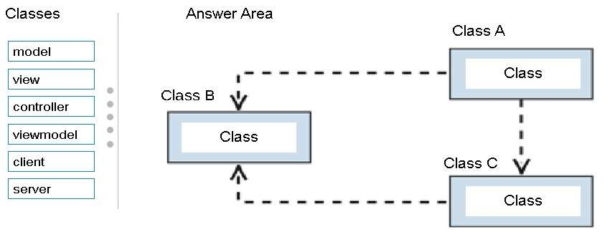

Answer:

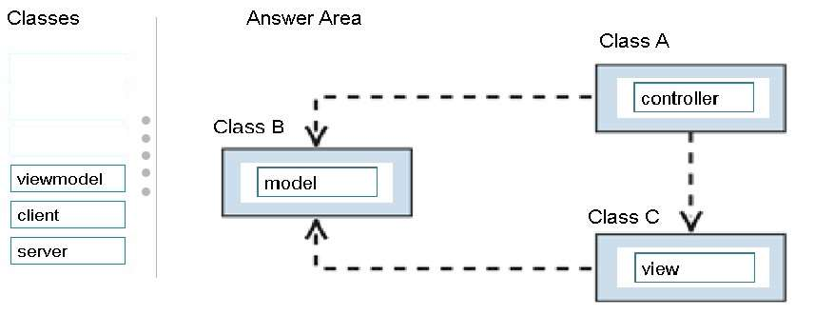

1. HOTSPOT

You are developing an ASP.NET MVC application that will be hosted on Microsoft Azure. The application includes the StackExchange.Redis client package. A variable named CacheConnectionConfiguration stores the cache endpoint URL and the password to connect to the cache. The application must store a user’s color selection by using the Azure Redis cache. The cached value must expire after 90 minutes. You need to cache the user’s color selection. How should you complete the relevant code? To answer, choose the appropriate code segment from each list in the answer area.

Hot Area:

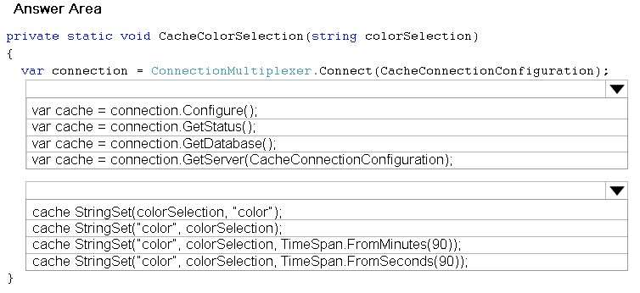

Answer:

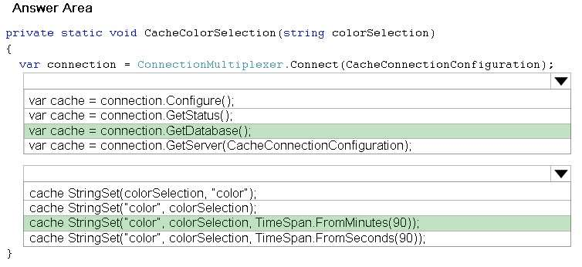

1. You deploy an ASP.NET MVC Web application to Internet Information Services (IIS). The application has a secure area that provides access to custom reports. You must develop custom business logic to support the reports. The custom business logic has the following requirements:

* It must run each time that a report is requested.
* It must not run for other IIS requests.
* It must be mapped to the request extension of the report.
* It must be written by using a managed language that is supported by the .NET framework.
* You must be able to quickly modify and deploy updates to the business logic.

You need to develop the custom business logic. What should you do?

1. Update the report logic to include the custom business logic. Use WebDAV to publish the reports to the server.
2. Develop a new HTTP module that includes the custom business logic. Deploy the HTTP module to IIS.
3. **Develop a new HTTP handler that includes the custom business logic. Deploy the HTTP handler to IIS.**
4. Develop a new ISAPI filter that includes the custom business logic. Deploy the ISAPI filter to IIS.
5. You are developing an ASP.NET MVC application that delivers real-time game results to sports fans. The application includes the following code. Line numbers are included for reference only.

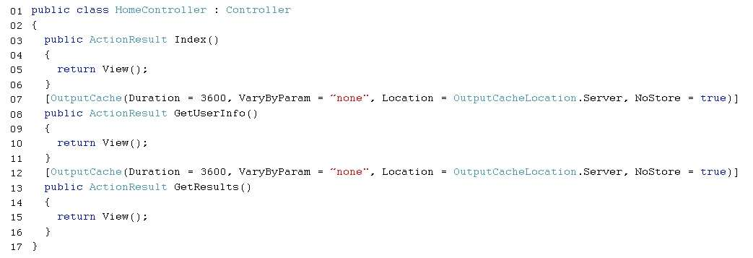

The source data for the game results is updated every 30 seconds. Testers report the following issues with the application:

* They report seeing other user’s name when they sign in to the application.
* They report delays in seeing the latest game results.

You need to correct the performance issues. Which two changes should you make to the code? Each correct answer presents part of the solution.

1. **Replace the code at line 07 with the following codesegment:**

**[OutputCache(Duration = 30, VaryByParam = “none”, Location = OutputCacheLocation.Client, NoStore = true)]**

1. **Replace the code at line 12 with the following code segment:**

**[OutputCache(Duration = 30, VaryByParam = “none”, Location = OutputCacheLocation.Server, NoStore = true)]**

1. Replace the code at line 07 with the following code segment:

[OutputCache(Duration = 3600, VaryByParam = “none”, Location = OutputCacheLocation.Server, NoStore = false)]

1. Replace the code at line 12 with the following code segment:

[OutputCache(Duration = 3600, VaryByParam = “none”, Location = OutputCacheLocation.Client, NoStore = true)]

1. HOTSPOT

You are preparing to test an ASP.NET application. The application includes the following class. Line numbers are included for reference only.

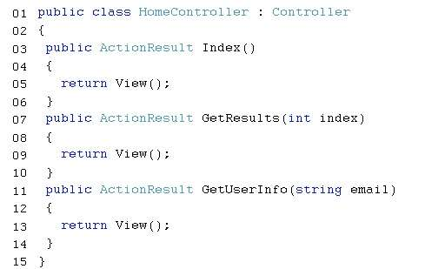

Data will be imported from another system into the current application. Before importing data, you must run unit tests to validate the data. To be considered valid, te data must meet the following requirements:

* The value passed into the GetResults method must be greater than or equal to zero.
* The value passed into the GetUserInfo method must not be null.

You need to create unit tests that fail if the requirements are not met. How should you complete the relevant code? To answer, select the appropriate code segment from each list in the answer area.

Hot Area:

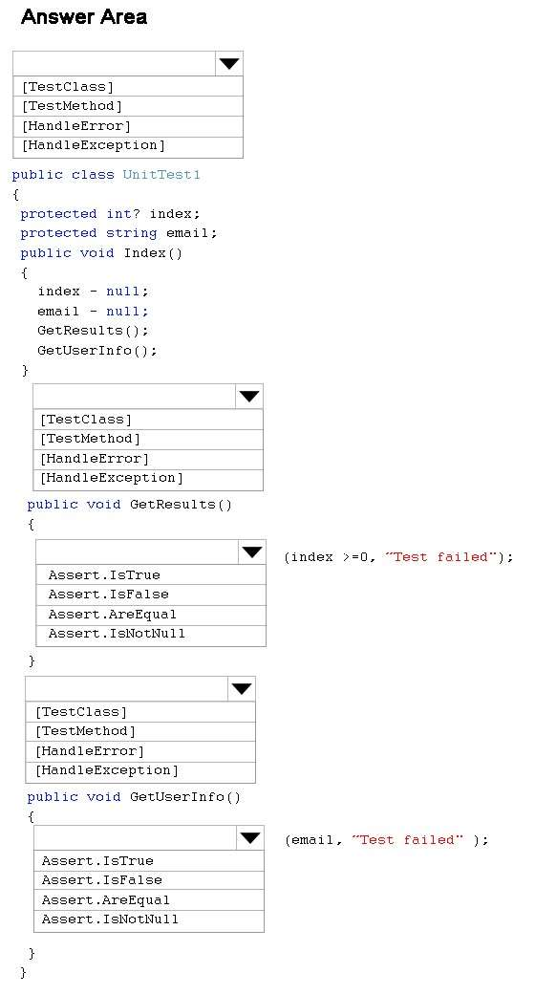

Answer:

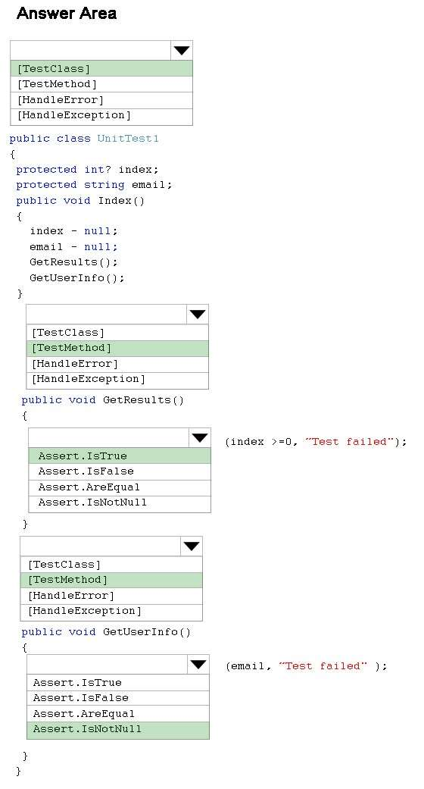

1. HOTSPOT

You are developing an ASP.NET MVC 4 application that includes the following class. Line numbers are included for reference only.

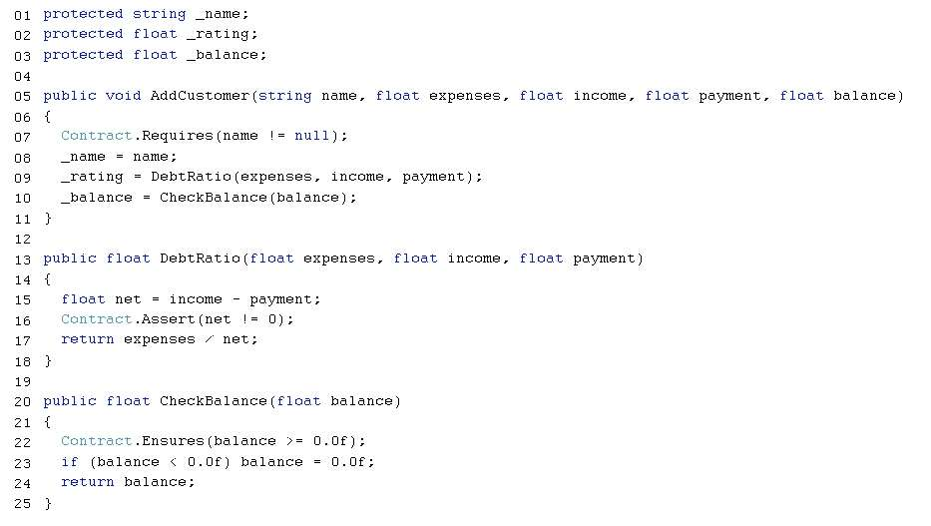

For each of the following statements, select Yes if the statement is true. Otherwise, select No.

Hot Area:

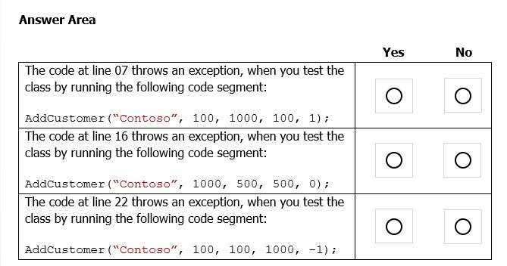

1. You are developing an ASP.NET application that allows users to download Microsoft Azure log files. You need to improve the performance of the application. What should you do?
2. Minify the content files.
3. Enable compression in IIS.
4. **Bundle the content files into a single .tar file.**
5. Host the image, JavaScript, and CSS files on a different server.
6. HOTSPOT

You develop a new ASP.NET MVC web application. The application is hosted in an Azure Web Role. It includes the following code. Line numbers are included for reference only.

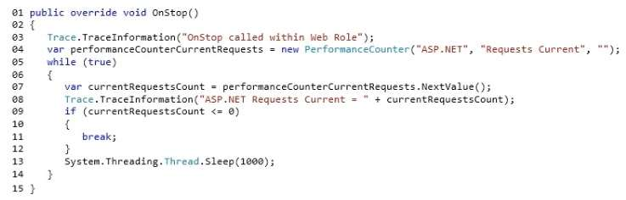

For each of the following statements, select Yes if the statement is true. Otherwise, select No.

Hot Area:

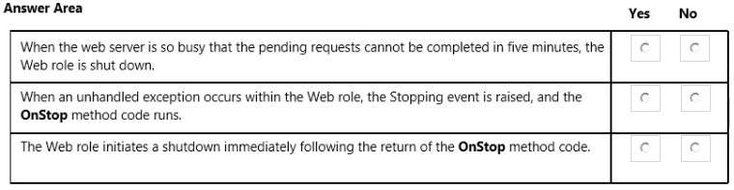

**Answer**:

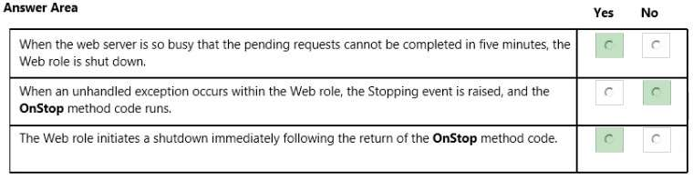

1. You are developing a new ASP.NET MVC application that will be hosted on Microsoft Azure. You need to implement caching. The caching solution must support the following:

* The cache must be able to store out-of-process ASP.NET session state.
* The cache must be able to store a variety of data types.
* The cache must offer a large amount of space for cached content.
* You must be able to share output cache content across web server instances.

You need to select a cache solution. Which caching solution should you choose?

1. ASP.NET Caching
2. Azure In-Role Cache
3. **Azure Redis Cache**
4. Azure Managed Cache Service
5. You are developing an ASP.NET MVC application that uses forms authentication. The application uses SQL queries that display customer order data. You need to prevent all SQL injection attacks against the application. How should you secure the queries?
6. **Implement parameterization.**
7. Pattern check the input.
8. Filter out prohibited words in the input.
9. Escape single quotes on string-based input parameters.
10. You are developing an ASP.NET MVC application that uses forms authentication against an Oracle database. You need to authenticate the users. Which code segment should you use?

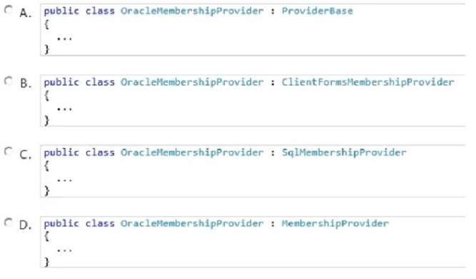

1. Option A
2. Option B
3. Option C
4. **Option D**
5. HOTSPOT

You develop an ASP.NET MVC application. The application includes a feature that allows users to reset their passwords. The feature is enabled by a ForgotPassword controller method and a corresponding Razor view. You need to prevent Cross-Site Request Forgery (CSRF) attacks. How should you complete the relevant code? To answer, select the appropriate code segment from each list in the answer area.

Hot Area:

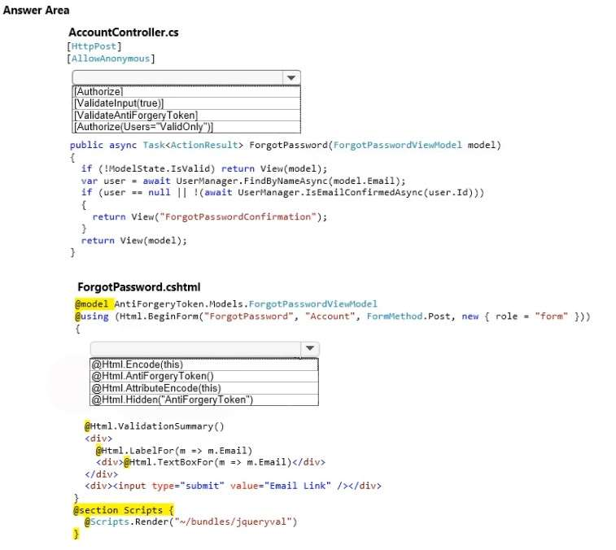

Answer:

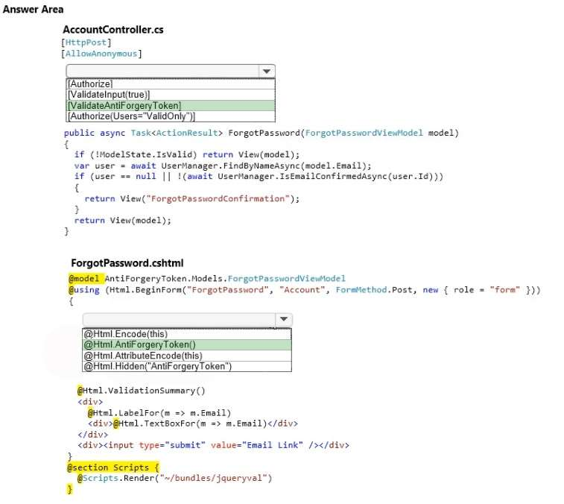

1. DRAG DROP

You are developing an ASP.NET MVC application in Visual Studio. The application contains an area that is defined as shown in the following graphic.

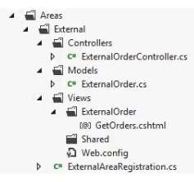

The ActionLink method must invoke the GetOrders() action in ExternalOrderController. You need to configure the parameters of the ActionLink method. You have the following markup.

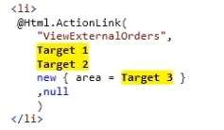

Which markup segments should you include in Target 1, Target 2 and Target 3 to complete the markup? To answer, drag the appropriate markup segment to the correct targets. Each markup segment may be used once, more than once, or not at all. You may need to drag the split bar between panes or scroll to view content.

Select and Place:

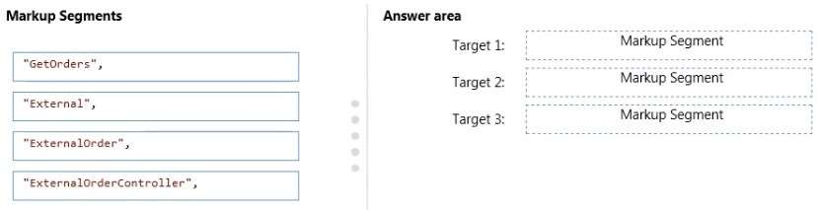

**Answer:**

**Target 1: GetOrders**

**Target 2: ExternalOrder**

**Target 3: External**

1. HOTSPOT

You are developing an ASP.NET MVC application. Before an action is executed, information about the action must be written to a log. After results are returned, information about the results also must be written to the log. You need to log the actions and results. You have the following code:

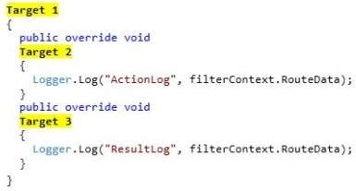

Which code segments should you include in Target 1, Target 2 and Target 3 to implement the LogActionFilter class? (To answer, select the appropriate option from the drop-down list in the answer area.)

Hot Area:

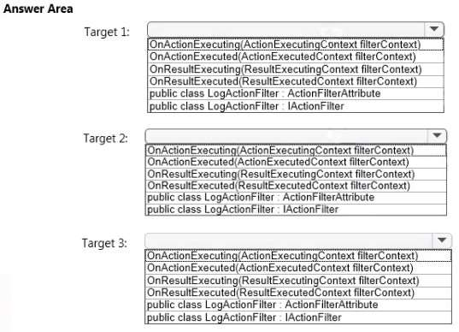

**Answer:**

**Target # 1 : public class LogActionFilter : ActionFilterAttribute**

**Target # 2 : OnActionExecuting(ActionExecutingContext filterContext)**

**Target # 3 : OnResultExecuted(ResultExecutedContext filterContext)**

1. HOTSPOT

You are developing an ASP.NET MVC application. The application includes the following code.

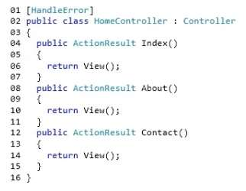

Line numbers are included for reference only. You add the following mark-up to the system.web section of the web.config file:

https://cdn.briefmenow.org/wp-content/uploads/70-486-v4/131.jpg

For each of the following statements, select Yes if the statement is true. Otherwise, select No.

Hot Area:

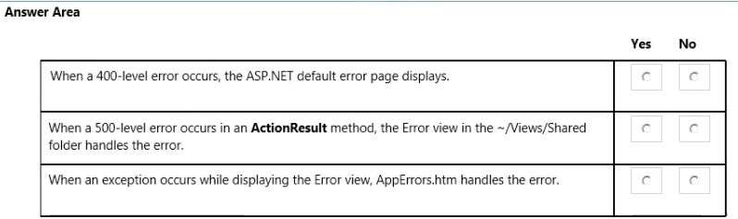

Answer:

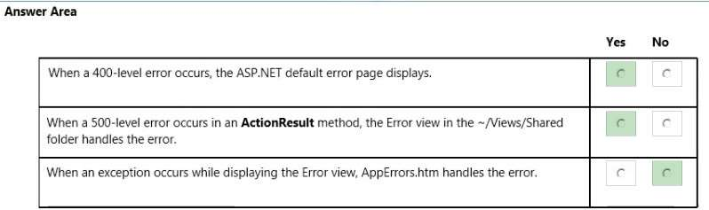

1. DRAG DROP

You are developing an ASP.NET web application that uses health monitoring to log evets to the Windows Event Log. The application contains a custom event that is defined in the following code segment. Line numbers are included for reference only.

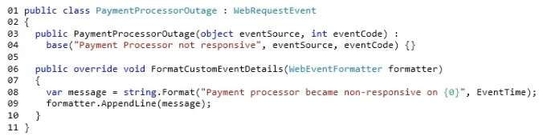

You need to ensure that the event is correctly added to the Windows event log. How should you complete the relevant code? To answer, drag the appropriate code segment to the correct location or locations. Each code segment may be used once, more than once, or not at all. You may need to drag the split bar between panes or scroll to view content.

Select and Place:

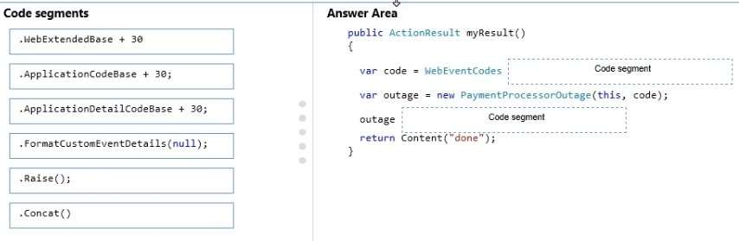

**Answer:**

* 1. **WebExtendedBase**
  2. **Raise**

1. You are developing an Azure worker role. You enable crash dump collection for the role. When the role starts, an external application stops responding. You need to download the crash dump to determine why the application stops responding. From which two locations can you download the crash dump? Each correct answer presents a complete solution.
2. **Azure Blob storage**
3. the temp folder on the virtual machine that is running the role instance
4. Azure file storage
5. **the DiagnosticStore local resource folder on the virtual machine that is running the role instance**
6. You are developing an ASP.NET MVC application that will run on Azure.The application uses Event Tracing for Windows (ETW) for logging operations. You need to retrieve the ETW data for the application froa deployed Azure instance by using the Azure Diagnostics API. Which data source should you use?
7. Azure Diagnostic infrastructure logs
8. Windows event logs
9. performance counters
10. **.NET EventSource**
11. You develop an ASP.NET MVC application. The application has a controller named PeopleController.cs. The controller has an action method that returns a parent view. The parent view includes the following code. Line numbers are included for the reference only.

The application also contains a partial view named People. The parent view must display the partial view. You need to add code at line 09 to display the partial view within the parent view. Which two code segments will achieve the goal? Each correct answer presents a complete solution.

1. **@{ Html.RenderPartial(“People”, Model);}**
2. **@Html.Partial(“People”, Model)**
3. @Html.Display(“People”, Model)
4. @Html.Raw(“People”)
5. You need to enable client-side validation for an ASP.NET MVC application. Which three actions should you perform? Each correct answer presents part of the solution.
6. Attach a custom validation attribute to the model properties that the view uses.
7. **Reference the jquery, jquery.validate and jquery.validate.unobtrusive script files in the view.**
8. **Open the web.config file at the project root, and set the values of the ClientValidationEnabled and UnobtrusiveJavaScriptEnabled keys to True.**
9. For each form element, use the Validator.element() method to validate each item.
10. **Add data annotations to the model properties that the view uses.**
11. HOTSPOT

You are developing an ASP.NET MVC application. The layout page of the application references the jQuery library. You develop a view that uses the layout page. The view includes the following markup:

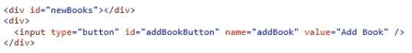

The application includes the following class:

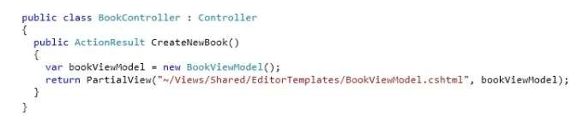

When a user clicks the button, an AJAX call must retrieve the partial view and append it to the newBooks div element. You need to implement the AJAX request. How should you complete the relevant code? To answer, select the appropriate code segment from each list in the answer area.

Hot Area:

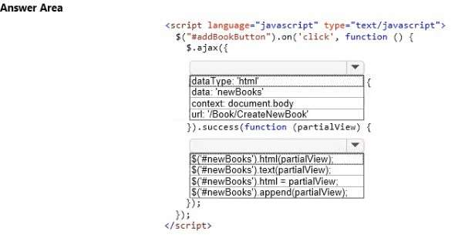

Answer:

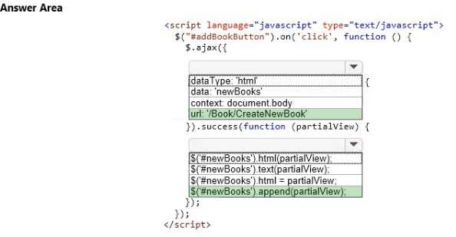

1. HOTSPOT

You are developing an ASP.NET MVC 4 application. You are using IntelliTrace to debug the application. You configure IntelliTrace as shown in the screenshot below.

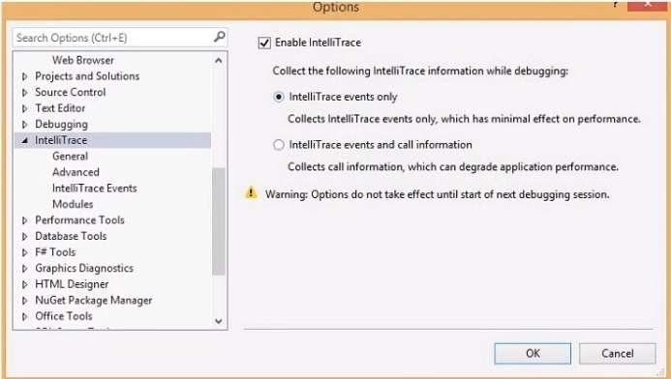

To answer, make the appropriate selections in the answer area.

Hot Area:

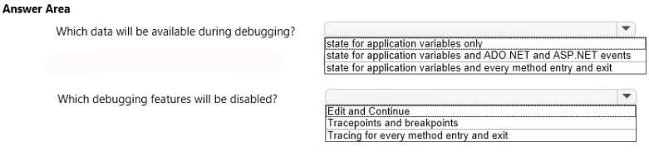

Answer:

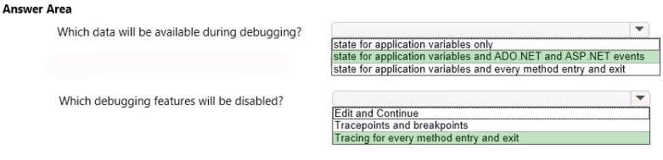

1. You are developing an application that uses many small images. When the images load, the application runs slowly. You need to improve the performance of the application. What should you do?
2. Preload all the images when the application starts to ensure that the images are cached.
3. Convert the images to ICO file format and stream all images on a single connection.
4. Host all images on a Microsoft Azure web role with multiple instances.
5. **Combine all the images into a single image and use CSS to create sprites.**
6. You are implementing a website redesign of an existing website that provides historical weather condition maps. The current layout resembles the following graphic.

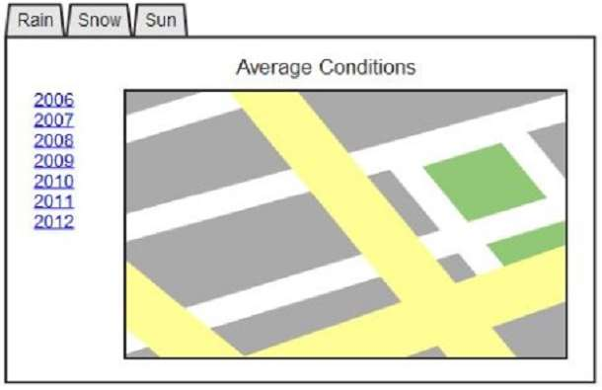

Year selection is implemented as a set of links, which causes the page to reload when the user changes the year. The year selection HTML is contained in a div with an id of “year-changer”. You need to modify the page so that the user can change the year without the page reloading. You also need to ensure that there is minimal change to the design of the page. Which code segment should you use?

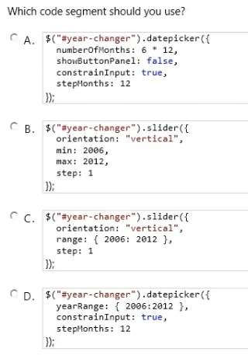

1. Option A
2. **Option B**
3. Option C
4. Option D
5. DRAG DROP

You are developing an ASP.NET MVC application in a web farm. The application has a page that accepts a customer’s order, processes it, and then redirects the browser to a page where the order is displayed along with the shipping information. The order information should be available only to the page where the order is displayed. You need to store state and configure the application. What should you do? To answer, drag the appropriate item to the correct location. Each item may be used once, more than once, or not at all. You may need to drag the split bar between panes or scroll to view content.

Select and Place:

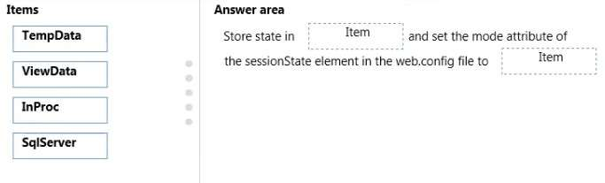

**Answer: TempData and SqlServer**

1. You are designing a distributed application. The application must store secure information that is specific to an individual user. The data must be automatically purged when the user logs off. You need to save transient information in a secure data store. Which data store should you use?
2. **Session state**
3. Database storage
4. Profile properties
5. Application state
6. You are designing an enterprise-level Windows Communication Foundation (WCF) application. User accounts will migrate from the existing system. The new system must be able to scale to accommodate the increasing load. The new servers are experiencing significant stress under load of large-scale role changes. You need to ensure that the application can handle the stress. Which authorizations should you redesign? (Each correct answer presents a complete solution. Choose all that apply.)
7. **Role-based approach**
8. **Identity-based approach**
9. Resource-based trusted subsystem model
10. Resource-based impersonation/delegation model
11. You are designing a localized ASP.NET MVC online shopping application that will be deployed to customers in the United States, China, France, and Brazil. The application must support multiple cultures so that content in the appropriate language is available in each area. You need to ensure that the content can be viewed in several languages. How should you implement this feature?
12. **Use a resource (.resx) file to provide translations.**
13. Use Systems.Collections.Generics.Dictionary to store alternative translations.
14. Ensure that all strings are marked internal to avoid conflict with internal literals.
15. Include language-specific content in the assembly manifest and use .NET culture libraries.
16. DRAG DROP

You are developing an ASP.NET MVC application in Visual Studio 2012. The application processes data for a bakery and contains a controller named BagelController.es that has several actions. The GetBagel action is defined in the following code segment.

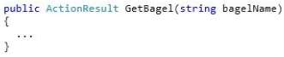

The GetBagel action is the only action that should be accessed via a URL pattern. Routes to the other actions in the controller must be suppressed. The default route must map to HomeController and the Index action. You need to build the routes.Which three code segments should you use in sequence? (To answer, move the appropriate actions from the list of actions to the answer area and arrange them in the correct order.)

Select and Place:

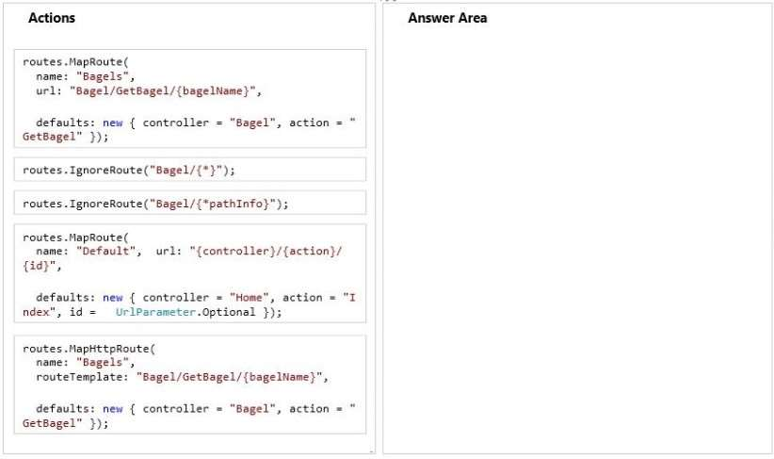

Answer:

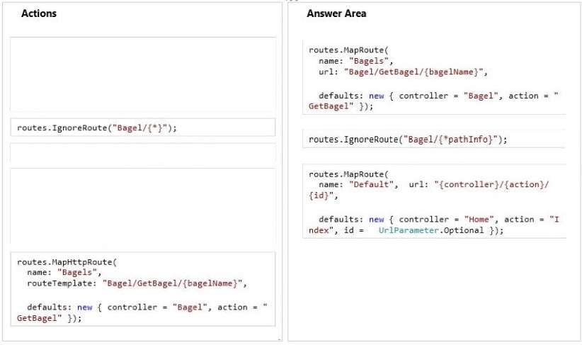

1. DRAG DROP

You are developing an ASP.NET MVC application in Visual Studio. The application supports multiple cultures. To set the culture, the application must use the AcceptLanguage header field value sent by the client browser. You need to ensure that the application can set the culture. You have the following markup in the web.config file:

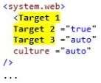

Which markup segments should you include in Target 1, Target 2 and Target 3 to complete markup? To answer, drag the appropriate markup segments to the correct targets. Each markup segment may be used once, more than once, or not at all. You may need to drag the split bar between panes or scroll to view content.

Select and Place:

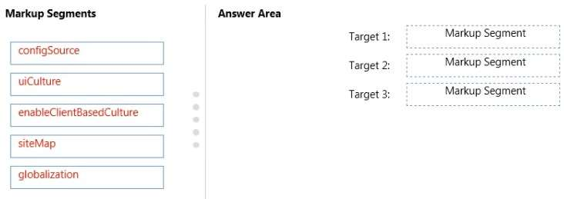

Answer:

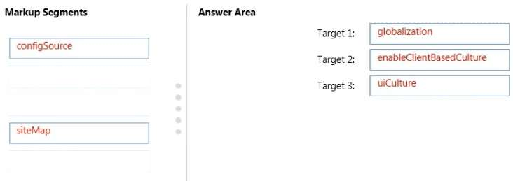

1. You are developing an application that uses many small images for various aspects of the interface.The application responds slowly when additional resources are being accessed. You need to improve the performance of the application. What should you do?
2. Preload all the images when the client connects to ensure that the images are cached.
3. Combine all the images into a single image and use CSS to create sprites.
4. **Host all images on an alternate server and provide a CDN.**
5. Convert the images to .png file format and stream all images on a single connection.
6. HOTSPOT

You are using the features of the IIS SEO Toolkit to configure the website. You need to exclude search engines from indexing parts of website. What should you do? (To answer, select the appropriate option from the drop-down list in the answer area.)

Hot Area:

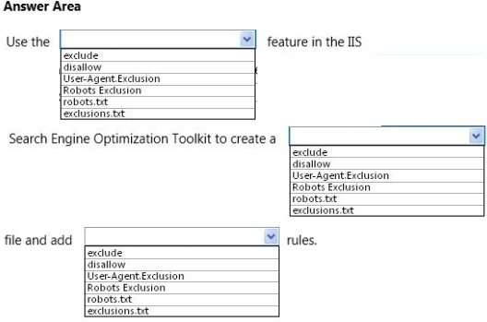

**Answer**:

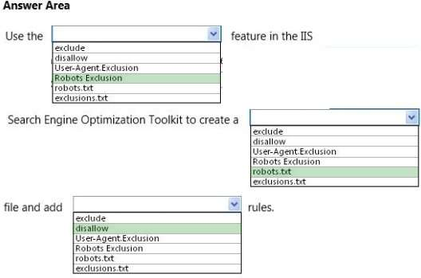

1. You are developing an ASP.NET MVC application that allows users to log on by using a third-party authenticator. You need to configure Microsoft Azure Access Control Services and the application. Which five actions should you perform in sequence? (To answer, move the appropriate actions from the list of actions to the answer area and arrange them in the correct order.)

Select and Place:

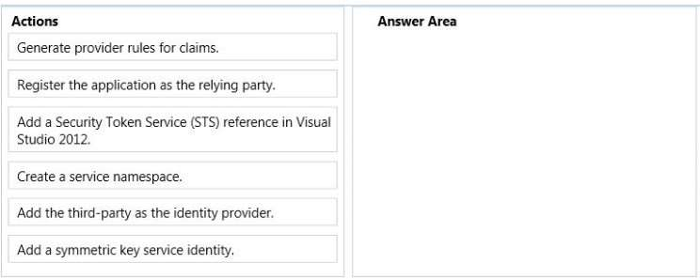

Answer:

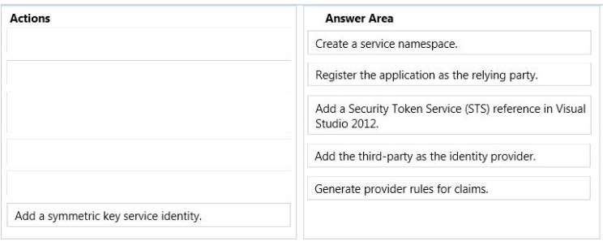

1. You are developing an ASP.NET MVC application that enables you to edit and save a student object.The application must not retrieve student objects on an HTTP POST request. You need to implement the controller. Which code segment should you use? (Each correct answer presents a complete solution. Choose all that apply.)

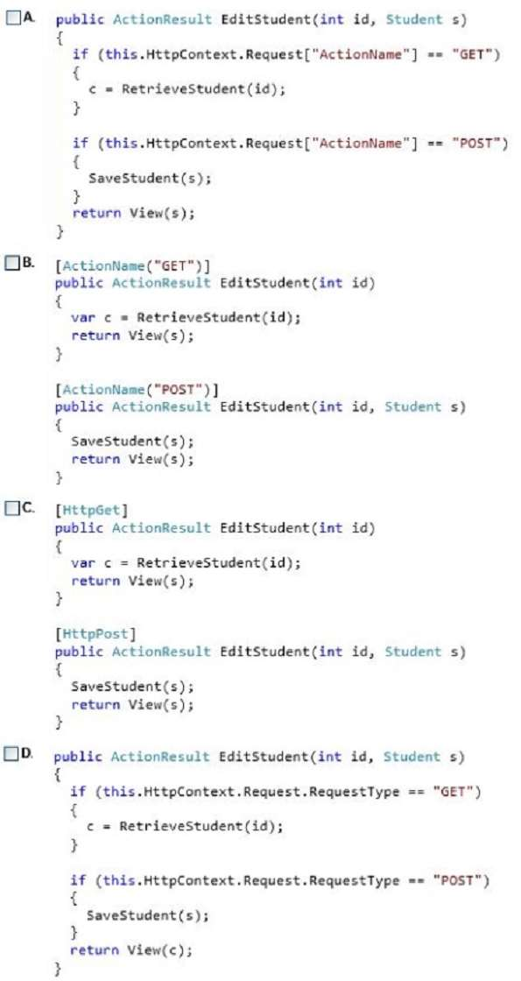

1. Option A
2. Option B
3. **Option C**
4. **Option D**
5. You are designing an MVC web application. The view must be as simple as possible for designers who do not have a technical background. You need to combine two existing models to meet the requirement. Which component of the MVC framework should you use?
6. View
7. **View Model**
8. Controller
9. Model
10. You are developing a controller for an ASP.NET MVC application that manages message board postings. The security protection built in to ASP.NET is preventing users from saving their HTML. You need to enable users to edit and save their HTML while maintaining existing security protection measures. Which code segment should you use?

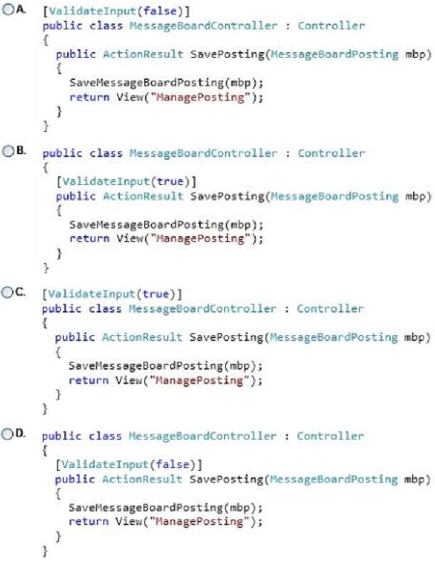

1. Option A
2. Option B
3. Option C
4. **Option D**
5. You are developing an ASP.NET MVC application to be used on the Internet. The environment uses Active Directory with delegation to access secure resources. Users must be able to log on to the application to maintain their personal preferences. You need to use the least amount of development effort to enable users to log on. What should you do?
6. Enable Forms authentication
7. **Enable Windows authentication**
8. Generate server SSL certificates and install them in IIS
9. Enable Digest authentication
10. DRAG DROP

You are building an ASP.NET MVC web application. The application will be viewed by users on their mobile phones. You need to ensure that the page fits within the horizontal width of the device screens. You have the following markup:

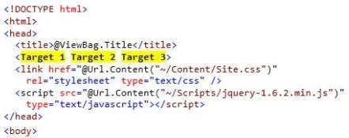

Which markup segments should you include in Target 1, Target 2 and Target 3 to complete the markup? (To answer, drag the appropriate markup segments to the correct targets. Each line of code may be used once, more than once, or not at all. You may need to drag the split bar between panes or scroll to view content.)

Select and Place:

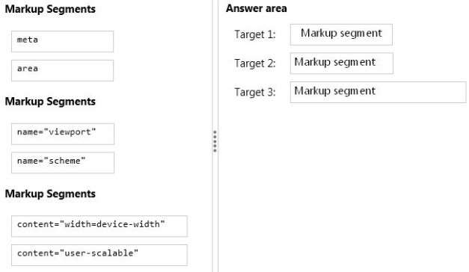

Answer:

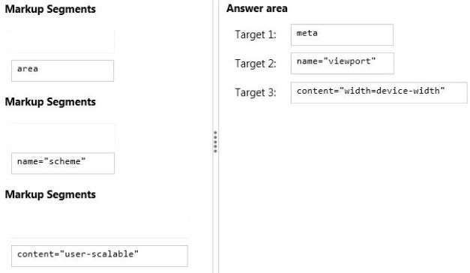

1. DRAG DROP

You are developing an ASP.NET MVC web application that requires HTML elements to take on new behaviors. These should be implemented with a behavior script in a page that is only for Microsoft Internet Explorer users. The colorchange.js script uses the Microsoft CSS vendor-specific Behavior extension. You need to apply the script with CSS. You need to use the script to change the color of text. You have the following markup:

https://cdn.briefmenow.org/wp-content/uploads/70-486-v4/92.jpg

Which styles should you include in Target 1 and Target 2 to complete the markup? (To answer, drag the appropriate styles to the correct targets. Each style may be used once, more than once, or not at all. You may need to drag the split bar between panes or scroll to view content.)

Select and Place:

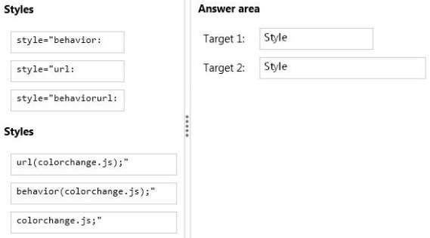

Answer:

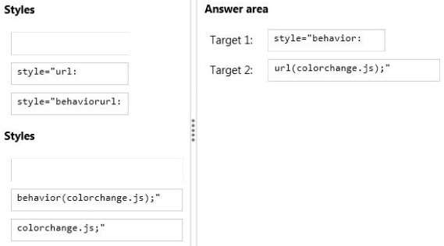

1. DRAG DROP

You are developing an ASP.NET MVC application in Visual Studio 2012. The application will be viewed with browsers on desktop devices and mobile devices. The application uses the Razor View Engine to display data. The application contains two layouts located in the /Views/Shared directory. These layouts are named:

_Layout.cshmtl

_MobleLayout.cshtml

The application must detect if the user is browsing from a mobile device. If the user is browsing from a mobile device, the application must use the _MobileLayout.cshtml file. If the user is browsing from a desktop device, the application must use .Layout, cs html. You need to ensure that the application renders the layout that is appropriate for the browser.

You have the following code:

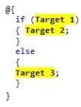

Which code segments should you include in Target 1, Target 2 and Target 3 to complete the code of the ViewStart.cshtml file? (To answer, drag the appropriate code segments to the correct targets. Each code segment may be used once, more than once, or not at all. You may need to drag the split bar between panes or scroll to view content.)

Select and Place:

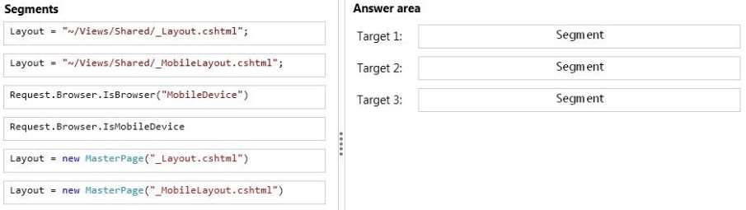

Answer:

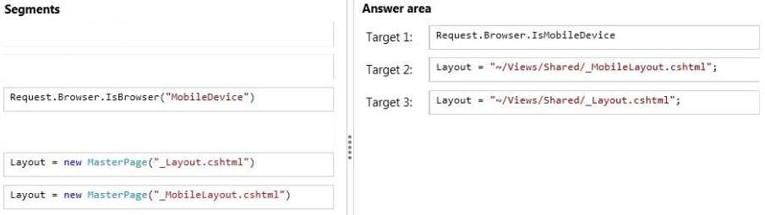

1. You are developing an ASP.NET MVC application that uses forms authentication against a third-party database. You need to authenticate the users. Which code segment should you use?

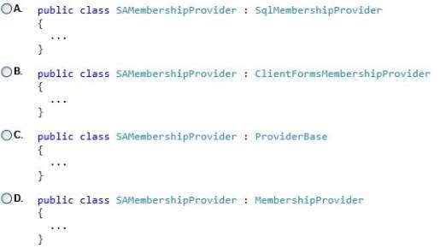

1. Option A
2. Option B
3. Option C
4. **Option D**
5. You are developing an ASP.NET MVC application that uses forms authentication to verify that the user is logged in. Authentication credentials must be encrypted and secure so no user identity is exposed. You need to ensure that user credentials are persisted after users log on. Where should you store the credentials? (Each correct answer presents a complete solution. Choose all that apply.)
6. **In Session on the server**
7. **In a cookie stored in the browser**
8. In ViewData in the application
9. In TempData on the server
10. You are developing an ASP.NET MVC application that provides instant messaging capabilities to customers. You have the following requirements:

* Messages must be able to be sent and received simultaneously.
* Latency and unnecessary header data must be eliminated.
* The application must comply with HTML5 standards.

You need to design the application to meet the requirements. What should you do?

1. Configure polling from the browser.
2. Implement long‐running HTTP requests.
3. **Implement WebSockets protocol on the client and the server.**
4. Instantiate a MessageChannel object on the client.
5. You are designing a data-oriented application that features a variety of storage schemas.

The application object model must be mapped to the various storage schemas. You need to enable developers to manipulate the data. Which ADO.NET data access strategy should you use? (Each correct answer presents a complete solution.

Choose all that apply.)

1. **LINQ to SQL**
2. **Entity Framework**
3. **DataAdapter**
4. DataReader
5. HOTSPOT

You are optimizing an Internet-facing website for search engine optimization. You are reading a Site Analysis Report from the SEO Toolkit. The report returns warnings that indicate the website HTML lacks key information necessary for search engine indexing. You need to improve the optimization of the site. What should you do? (To answer, select the appropriate option from the drop-down list in the answer area.)

Hot Area:

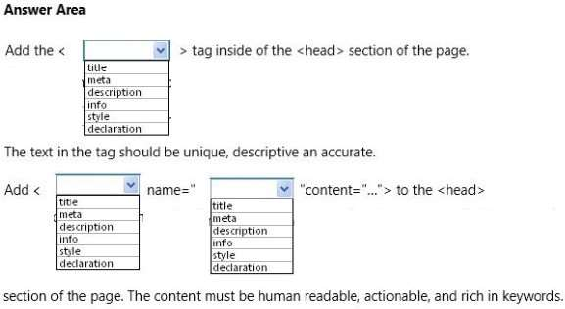

Answer:

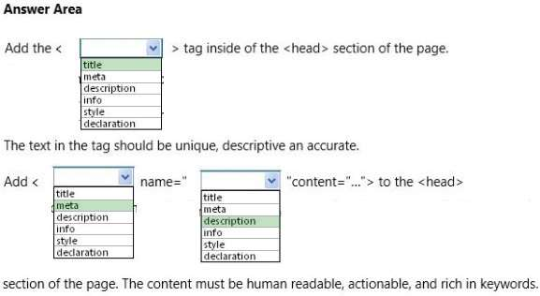

1. DRAG DROP

You are developing an ASP.NET MVC application. The application has a view that displays a list of orders in a multi-select list box. You need to enable users to select multiple orders and submit them for processing. What should you do? (To answer, drag the appropriate words to the correct targets. Each word may be used once, more than once, or not at all. You may need to drag the split bar between panes or scroll to view content.)

Select and Place:

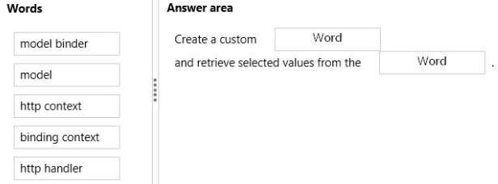

Answer:

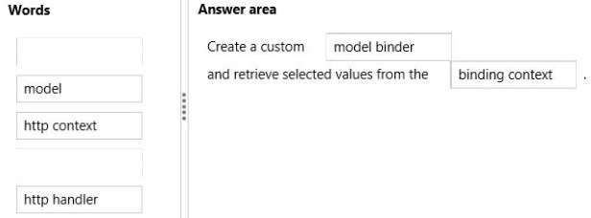

1. You are preparing for the deployment of an ASP.NET MVC application. You need to generate a deployment manifest. Which command-line tool should you use?
2. **Mage.exe**
3. Ngen.exe
4. ALexe
5. Resgen.exe
6. You are developing an application that supports multiple cultures. The application must store localized content in satellite assemblies. You need to build the satellite assemblies. Which tool should you use?
7. Gacutil.exe
8. **Al.exe**
9. Ildasm.exe
10. Ilasm.exe
11. You are designing a distributed banking application that handles multiple customers. A user may log on to the site to perform activities such as checking balances, performing transactions, and other activities that must be done securely. The application must store secure information that is specific to an individual user. The data must be automatically and securely purged when the user logs off. You need to save transient information in a secure data store. Which data store should you use?
12. **NET session state**
13. NET profile properties
14. NET application state
15. Shared database
16. You are developing an ASP.NET MVC web application for viewing a photo album. The application is designed for devices that support changes in orientation, such as tablets and smartphones. The application displays a grid of photos in portrait mode. When the orientation changes to landscape, each tile in the grid expands to include a description. The HTML that creates the gallery interface resembles the following markup.If this CSS is omitted, the existing CSS displays the tiles in landscape mode.

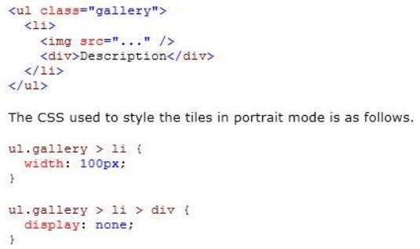

You need to update the portrait mode CSS to apply only to screens with a width less than 500 pixels. Which code segment should you use?

1. @media resolution(max-width: 500px) {. . .}
2. @media screen(min-width: Opx, max-width: 500px) {. . .}
3. @media screen and (width <= 500px) {. . .}
4. **@media screen and (max-width: 500px) {. . .}**
5. You are developing an ASP.NET MVC application by using Visual Studio 2012. The application throws and handles exceptions when it runs. You need to examine the state of the application when exceptions are thrown. What should you do?
6. **From the Debug menu in Visual Studio 2012, select Exceptions. Enable the Thrown check box for Common Language Runtime Exceptions.**
7. From the DEBUG menu in Visual Studio 2012, select Attach to Process. Select the IIS process.
8. From the Debug menu in Visual Studio 2012, select Exceptions. Disable the User-unhandled check box for Common Language Runtime Exceptions.
9. From the TOOLS menu in Visual Studio 2012, click Customize. Click the Command tab and select Debug.
10. You are developing an ASP.NET MVC application that will be deployed on a web farm. Passwords must be stored in the web.config file and must not be readable or in a format that is easily decodable. You need to encrypt the passwords that are stored in the web.config file. Which command-line tool should you use?
11. **Aspnet_regiis.exe**
12. Aspnet_regbrowsers.exe
13. Aspnet_setreg.exe
14. Aspnet_compiler.exe
15. You are developing an ASP.NET MVC application in Visual Studio 2012. The application supports multiple cultures. The application contains three resource files in the Resources directory:

ProductDictionary.resx

ProductDictionary.es.resx

ProductDictionary.fr.resx

Each file contains a public resource named Currency with the localized currency symbol. The application is configured to set the culture based on the client browser settings. The application contains a controller with the action defined in the following code segment. (Line numbers are included for reference only.)

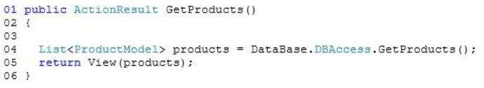

You need to set ViewBag.LocalizedCurrency to the localized currency contained in the resource files. Which code segment should you add to the action at line 03?

1. **ViewBag.LocaIizedCurrency = Resources.ProductDictionary.Currency;**
2. VievBag.LocalizedCurrency = HttpContext.GetGlobalResourceObject(“ProductDictionary”, “Currency”, new System.Globalization.CultureInfo(Men”));
3. VievBag.LocalizedCurrency = HttpContext.GetLocalResourceObject(“ProductDictionary”,”Currency”);
4. ViewBag.LocalizedCurrency = HttpContext.GetGlobalResourceObject(“ProductDictionary”, “Currency”);
5. HOTSPOT

You are developing an ASP.NET MVC web application that enables users to open Microsoft Excel files. The current implementation of the ExcelResult class is as follows.

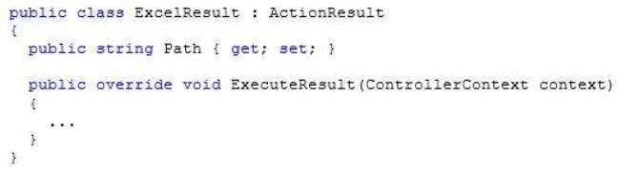

You need to enable users to open Excel files.How should you implement the ExecuteResult method? (To answer, select the appropriate options in the answer area.)

Hot Area:

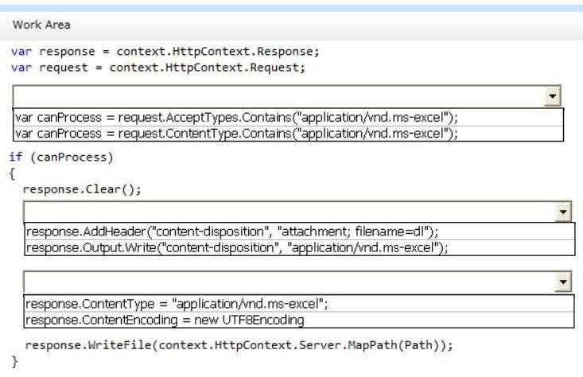

Answer:

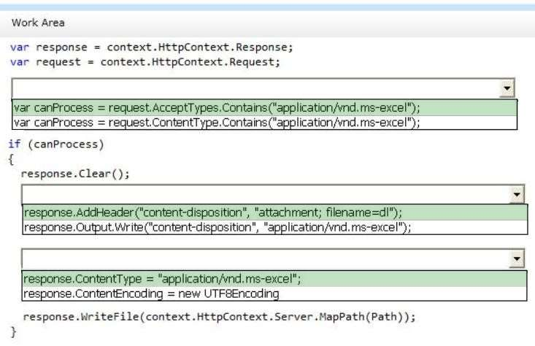

1. You are designing a distributed application. The application must store a small amount of insecure global information that does not change frequently. You need to configure the application to meet the requirements. Which server-side state management option should you use? (Each correct answer presents a complete solution. Choose all that apply.)
2. **Application state**
3. Session state
4. **Database support**
5. Profile properties
6. HOTSPOT

You are developing an ASP.NET MVC application. You need to store membership information in a Microsoft SQL Server database. How should you configure the membership provider? (To answer, select the appropriate options in the answer area.)

Hot Area:

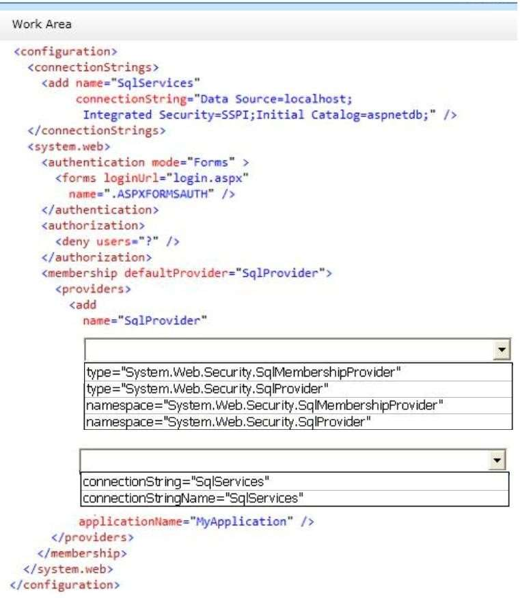

Answer:

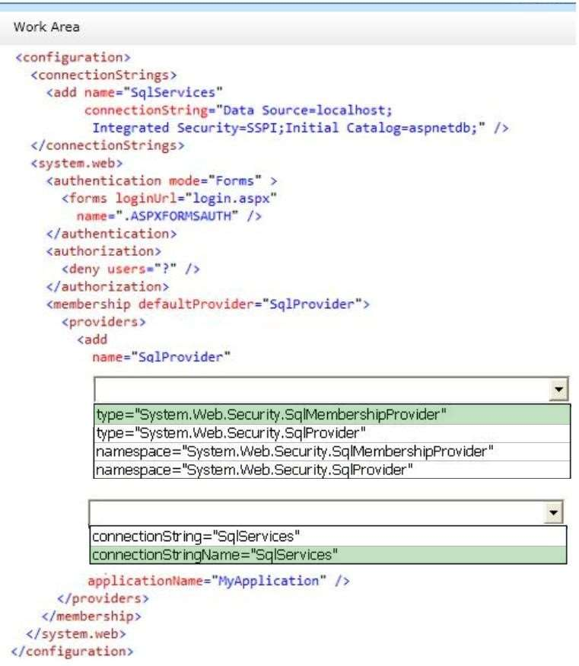

1. HOTSPOT

You are developing an ASP.NET MVC application that authenticates a user by using claims-based authentication. The application must:

* Use Windows Identity Foundation 4.5.
* Support the Windows Azure Access Control Service.

You need to implement authentication. How should you build the class constructor? (To answer, select the appropriate option from the drop-down list in the answer area.)

Hot Area:

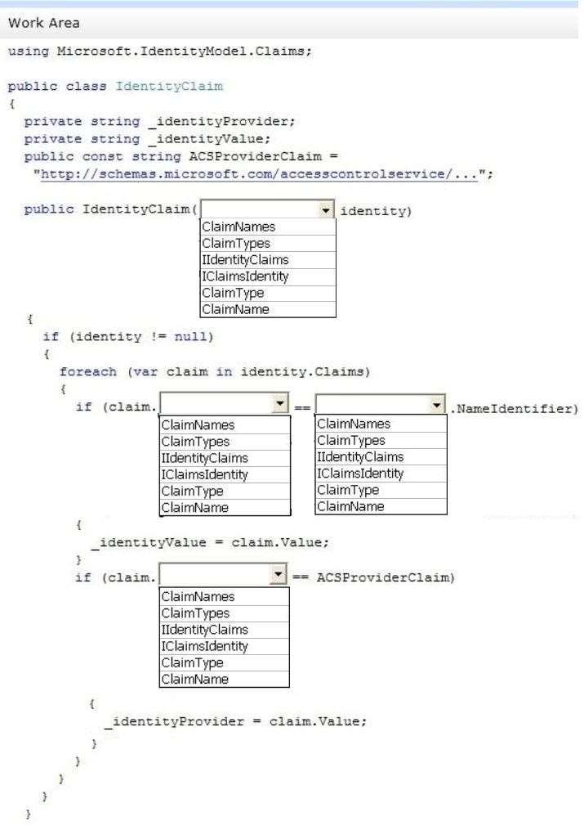

Answer:

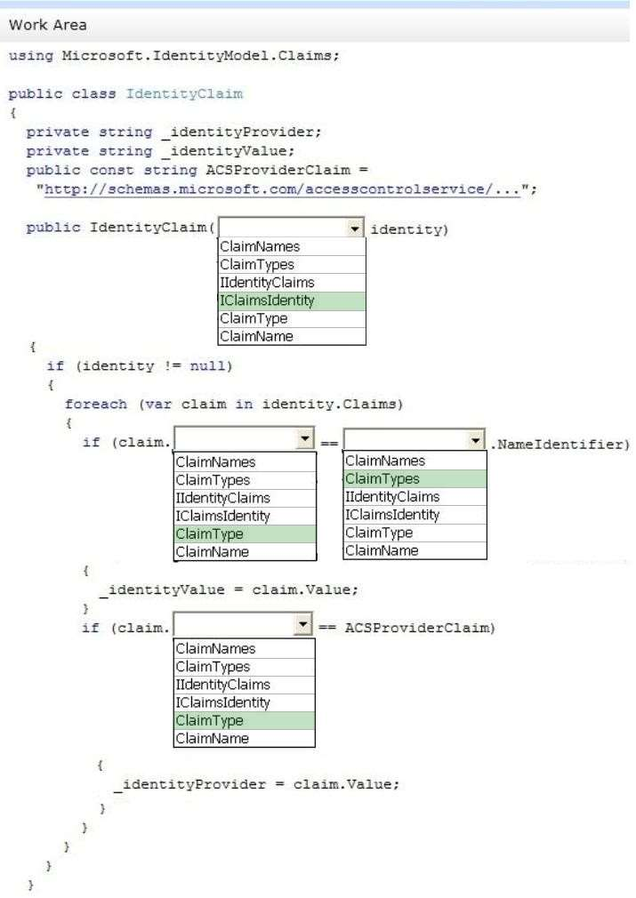

1. DRAG DROP

You are developing an ASP.NET MVC application in Visual Studio. The application contains sensitive bank account data. The application contains a helper class named SensitiveData.Helpers.CustomEncryptor.

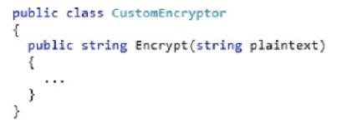

The application contains a controller named BankAccountController with two actions.

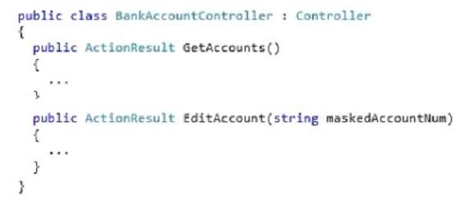

The application contains a model named BankAccount, which is defined in the following code segment.

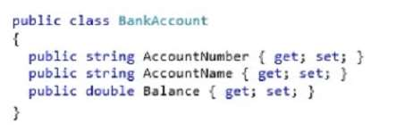

The application must not display AccountNumber in clear text in any URL. You need to build the view for the GetAccounts action. You have the following code:

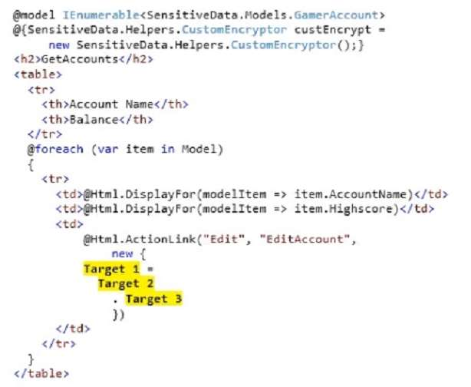

Which code segments should you include in Target 1, Target 2 and Target 3 to build the view? To answer, drag the appropriate code segment to the correct targets. Each code segment may be used once, more than once, or not at all. You may need to drag the split bar between panes or scroll to view content.

Select and Place:

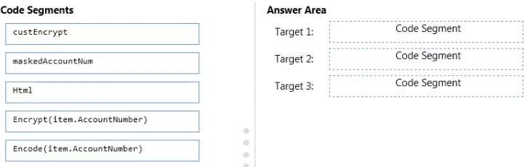

Answer:

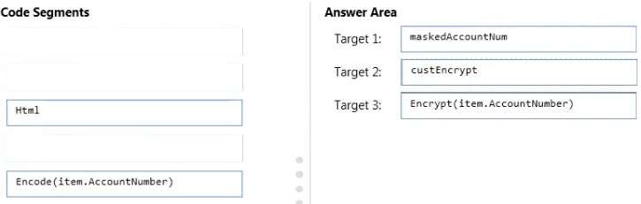

1. You are developing an ASP.NET MVC application. The application must allow users to enter JavaScript in a feedback text box only. You need to disable request validation. What should you do?
2. Apply and set the CausesClientSideValidation attribute on the text box to FALSE.
3. Apply and set the ValidateInput attributeon the text box to FALSE.
4. **Use the HttpRequest.Unvalidated property to read the unvalidated form value.**
5. Use the HttpRequest.Form property to read the unvalidated form value.
6. You are developing an ASP.NET MVC application. You need to authenticate clients by using NT LAN Manager (NTLM). Which authentication method should you implement?
7. Basic
8. Windows
9. Forms
10. Kerberos
11. You are developing an ASP.NET MVC application. You need to authenticate clients by using NT LAN Manager (NTLM). Which authentication method should you implement?
12. Basic
13. **Windows**
14. Forms
15. Kerberos
16. DRAG DROP

You are developing an ASP.NET MVC application that has pages for users who browse the site with Windows Phone 7. The pages for Windows Phone 7 include the following files:

* _Layout.WP7.cshtml
* Index.WP7.cshtml

You need to update the application so that it renders the customized files correctly to Windows Phone 7 users. How should you update the Application_Start method? (To answer, drag the appropriate line of code to the correct location or locations. Each line of code may be used once, more than once, or not at all. You may need to drag the split bar between panes or scroll to view content.)

Select and Place:

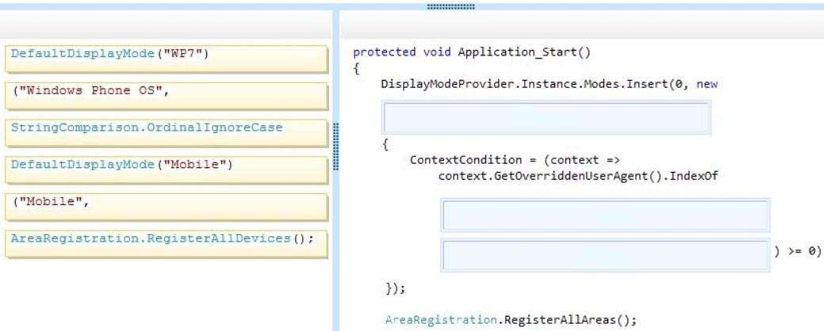

Answer:

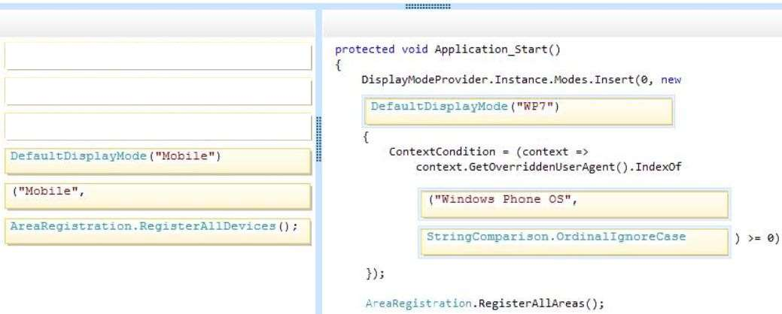

1. You are designing a distributed application that runs on the Microsoft Azure platform. The application must store a small amount of information that is shared cross all users and does not change frequently. You need to configure the application to meet the requirements.Which server-side state management option should you use? (Each correct answer presents a complete solution. Choose all that apply.)
2. Microsoft Azure application state
3. **SQL Database**
4. Profile properties of the Microsoft Azure application
5. Microsoft Azure session state
6. You are developing an ASP.NET MVC application that displays stock market information. The stock market information updates frequently and must be displayed in real-time. You need to eliminate unnecessary header data, minimize latency, and transmit data over a full-duplex connection. What should you do?
7. Implement long-running HTTP requests.
8. Instantiate a MessageChannel object on the client.
9. **Implement WebSockets protocol on the client and the server.**
10. Configure polling from the browser.
11. You are developing an ASP.NET MVC application. The application is deployed in a web farm and is accessed by many users. The application must handle web server failures gracefully. The servers in the farm must share the state information. You need to persist the application state during the session. What should you implement?
12. **A state server**
13. Cookieless sessions
14. A web garden on the web servers
15. An InProc session
16. You are developing an ASP.NET MVC news aggregation application that will be deployed to servers on multiple networks. The application must be compatible with multiple browsers. A user can search the website for news articles. You must track the page number that the user is viewing in search results. You need to program the location for storing state information about the user’s search. What should you do?
17. Store search results and page index in Session.
18. Use Application state to store search terms and page index.
19. **Use QueryString to store search terms and page index.**
20. Store search results and page index in TempData
21. DRAG DROP

You are developing an ASP.NET MVC application that takes customer orders. Orders are restricted to customers with IP addresses based in the United States. You need to implement a custom route handler. How should you implement the route handler? (To answer, drag the appropriate line of code to the correct location or locations. Each line of code may be used once, more than once, or not at all. You may need to drag the split bar between panes or scroll to view content.)

Select and Place:

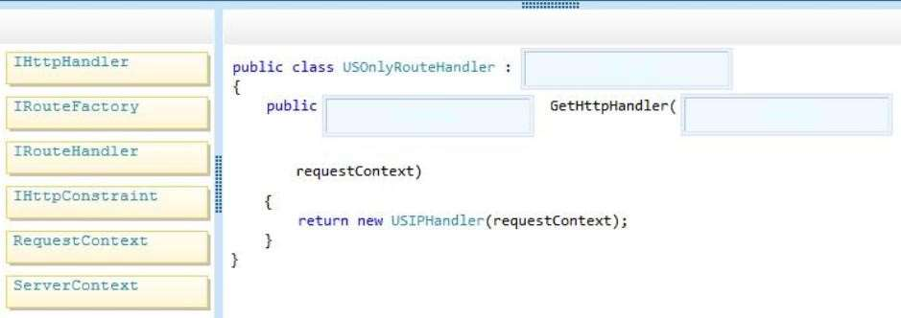

Answer:

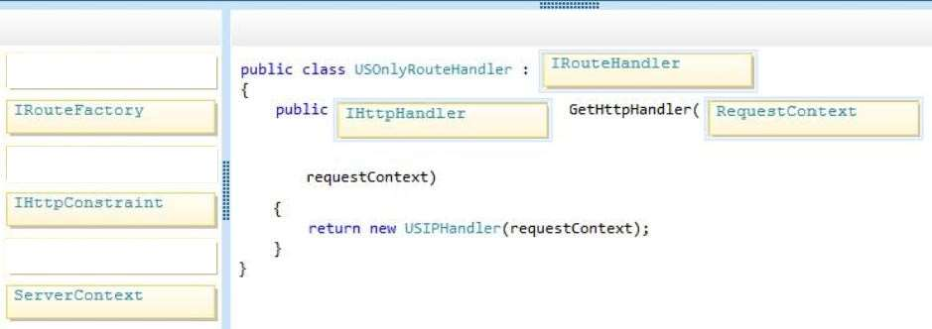

1. You are developing an ASP.NET MVC application. The application uses a SQL Server database and a SQL Server login and password. You need to ensure that the password for the SQL Server login is not stored in plain text. Which two actions should you perform? Each correct answer presents part of the solution.
2. **Ensure that there is a valid machineKey element in the web.config file.**
3. **Encrypt the connection string by using aspnet_regiis.exe.**
4. Ensure that there is a valid encryptionKey element in the web.config file.
5. Encrypt the connection string by using aspnet_wp.exe5
6. You develop a new ASP.NET MVC application. You use local storage to maintain state. The localstorage object's setitem method is failing to store a value. Which two scenarios will cause the failure? Each correct answer presents a complete solution.
7. **The user has disabled local storage in the browser.**
8. The newValue property was used prior to calling the setitem method.
9. The value being stored is a JavaScript array.
10. **The value being stored exceeds I0MB in size.**
11. You are maintaining an ASP.NET MVC application that runs on Azure. Remote debugging Is enabled for this role, but the input endpoints for remote debugging have been removed for security reasons. You do not have permission to view the Azure Portal for this deployment. You can log on by using Remote Desktop Protocol (RDP). You must attach a remote debugger to the application. You need to add the input endpoints to enable remote debugging. Which file should you modify?
12. **E:\.csman**
13. C:\Config\.ccf
14. C:\Config\WebRole.1.xml
15. E:\entrypoint.txt
16. You are developing an ASP.NET MW application that will be deployed on local Internet Information Services (IIS} servers and on a Azure Web Role. You must log events for the application when It's deployed locally and on Azure. You must not deploy additional services. You need to implement a logging solution. Which two technologies can you use? Each correct answer represents a complete solution.
17. **event log**
18. console
19. named pipe
20. **Trace**
21. How could you traditionally consume an ASMX web service from your application? (Choose all that apply.)
22. Generate a proxy by selecting Add Reference In Visual Studio.
23. **Create an HttpService and connect using Get(URL).**
24. **Generate a proxy by selecting Add A Service Reference in Visual Studio.**
25. Create a WCF proxy class.
26. You are designing an ASP.NET MVC 4 application that uses an Oracle database for persistence. What session configuration choices enable you to deploy your application on a web farm? (Choose all that apply.)
27. InProc
28. SQLServer
29. **StateServer**
30. **Custom session provider**
31. You are creating an ASP.NET MVC web application. The application must accept user input for a ProductName field. To reduce delays due to invalid entries making round trips between the client and server, user input should be validated on the client before being submitted to the server. Which code segment should you choose?
32. <div class="editor-label">

@Html.LabelFor(model => model.ProductName)

</div>

<div class="editor-field">

@Html.EditorFor(model => model.ProductName)

</div>

1. <div class="editor-label">

@Html.LabelFor(model => model.ProductName)

</div>

<div class="editor-field">

@Html.ValidationMessageFor (model => model.ProductName)

</div>

1. **<div class="editor-field">**

**@Html.EditorFor(model => model.ProductName)**

**@Html.ValidationMessageFor(model => model.ProductName)**

**</div>**

1. <div class="editor-label">

@Html.LabelFor(model => model.ProductName)

</div>

1. You are creating an ASP.NET MVC web application. Within the application, you have created a partial view for contact email and phone number. Which code segment should you use to display the partial view on the main page?
2. <div class="float-right">

<section id="contact">

@Html.ActionLink("ContactPartial")

</section>

</div>

1. **<div class="float-right">**

**<section id="contact">**

**@Html.Partial("ContactPartial")**

**</section>**

**</div>**

1. <div class="float-right">

<section id="contact">

@RenderPage("ContactPartial")

</section>

</div>

1. <div class="float-right">

<section id="contact">

@RenderBody()

</section>

</div>

1. You are developing an application. One requirement is that part of your data access layer needs to be available to a third party, that wants to get this information from a REST URL in XML. Your company does not have experience with web services, but you have several websites running ASP.NET MVC 4. How could you design and provide these new services? (Choose all that apply.)
2. Task an individual on staff to learn WCF, and have this individual develop and deploy these new services using WCF.
3. **Use the Web API to create REST services using ApiController in which the serialization type is defined by the Accepts property of the browser.**
4. **Build a basic ASP.NET MVC 4 project in which the view simply passes through the information provided by the controller, and the controller manages the code for serializing the response.**
5. Create an ASP.NET ASMX services file to get, serialize, and return the data.